

PROJECT PROPOSAL
MAY 2026 SEMESTER
WEB BASED FLORIST MANAGEMENT SYSTEM
BY
AMANDA ANASTASYA ARYANTO
SCHOOL OF SCIENCE AND TECHNOLOGY ASIA e UNIVERSITY
This report is prepared to fulfill the requirement of CPP400 Project Proposal
By
AMANDA ANASTASYA ARYANTO
C3010930145

SCHOOL OF SCIENCE AND TECHNOLOGY
ASIA e UNIVERSITY
MAY 2026 SEMESTER

DISCLAIMER
CPP400 – PROJECT PROPOSAL
I am responsible for the accuracy of all opinion, technical comment, factual report, data, figure, illustrations and photographs highlighted in this report. I bear full responsibility that the report submitted has been reviewed and subject to copyright or ownership rights. Asia e University will not bear any liability for the accuracy of any comment, report and other technical and factual information, and the copyright or ownership right claims.
AMANDA ANASTASYA ARYANTO
C3010930145

ACKNOWLEDGEMENT
Praise be to the presence of God, for it is by His blessings and mercy that the author was able to complete this project successfully. Throughout the process of preparing and writing this Project Proposal, the author received abundant guidance and support, allowing its timely completion.
The author would like to express sincere gratitude to Ts. Dr. Husna Sarirah Husin, the academic facilitator, for her invaluable assistance and guidance throughout this journey. Her insightful advice, encouragement, and ideas played a significant role in shaping and completing this proposal.
Special thanks are also extended to the author’s family and friends, whose continuous support and encouragement were instrumental during the development of this project.
This Project Proposal has not only been an academic task but also a meaningful learning journey. The author has gained many new insights and experiences, and is committed to applying this knowledge for the benefit of others in the future.
Thank you.

ABSTRACT

In the digital era, florist businesses still largely depend on manual processes such as phone calls and WhatsApp messaging, leading to inefficient order management and inaccurate inventory tracking. This project proposes a web-based Florist Management System that streamlines bouquet inventory, order processing, and customer management for both customers and admins. The system is developed using PHP Laravel as the backend framework, MySQL as the database, and Bootstrap 5 for the frontend interface. Beyond standard management functions, it introduces two innovative features: a Smart Bouquet Recommendation Wizard and a Smart Reminder System for occasion-based notifications. This system is expected to reduce manual effort, minimise order errors, and improve customer satisfaction for florist businesses transitioning into the digital era.

Keywords: Florist Management System, Web-Based Application, Smart Recommendation System, Automated Reminder System, Inventory Management, E-Commerce, Agile Methodology.

TABLE OF CONTENT

DISCLAIMER 1
ACKNOWLEDGEMENT 2
ABSTRACT 3
TABLE OF CONTENT 1
Chapter 1: Introduction 1
1.1 Problem Statement 1
1.2 Objectives 2
1.3 System Scope 3
1.4 Target User 3
1.5 Methodology 3
1.6 Project Timeline 4
Chapter 2: Literature Review 7
2.1 Introduction 7
2.2 Review on the Existing System 8
2.2.1 Existing System 1 8
2.2.2 Existing System 2 10
2.2.3 Existing System 3 12
2.2.4 Comparison with the Florist Management System 14
2.3 Review of Core Technologies & Frameworks (Tech Stack Justification) 15
2.4 Review of Relevant Algorithms or Architectural Patterns 17
2.5 Summary & Synthesis (The Research Gap) 19
Chapter 3 20
SYSTEM ANALYSIS 20
3.1 Introduction 20
3.1.1 Purpose 20
3.1.2 SWOT Analysis 21
3.1.3 Scope 22
3.2 System Development Process 27
3.2.1 Requirement Gathering 28
3.2.2 System Design 29
3.2.3 Implementation 29
3.2.4 Testing 29
3.2.5 Deployment 30
3.2.6 Maintenance 30
3.3 System Modeling 30
CHAPTER 4 32
SYSTEM DESIGN 32
4.1 Introduction 32
4.2 Design Forms and Report 33
4.2.1 Site Map 33
4.2.2 UML Diagrams 33
4.2.3 Screen Flow / User Interface 41
4.3 References 45
4.4 Appendix 46

Chapter 1: Introduction
The advancement of internet technology has significantly transformed the way businesses operate and interact with their customers. Many industries have embraced digital solutions to improve efficiency, reduce manual workload, and enhance customer experience. The florist industry, however, remains largely dependent on traditional and manual processes, creating inefficiencies that affect both business owners and their customers.
This project presents the development of a web-based Florist Management System — a digital platform designed to help florist businesses manage their daily operations, including bouquet inventory, customer orders, and customer relationship management. Beyond standard management features, the system incorporates two innovative capabilities: a Smart Reminder System that automatically notifies customers about upcoming occasions, and a Smart Bouquet Recommendation Wizard that guides customers in selecting the most suitable bouquet based on their preferences.
By leveraging modern web technologies, this system aims to bring florist businesses into the digital era, reducing manual effort while delivering a more personalised and convenient experience for customers.

1.1 Problem Statement
Florist businesses that rely on manual processes face several operational challenges that limit their growth and service quality. Based on observation and analysis of traditional florist operations, the following problems have been identified:
- Manual order management is inefficient. Most florist businesses record customer orders through phone calls, handwritten notes, or basic messaging applications such as WhatsApp. This approach is prone to human error, makes it difficult to track order status, and creates confusion during peak seasons such as Valentine's Day and Mother's Day when order volumes increase significantly.
- Inventory management lacks accuracy. Without a centralised system, business owners struggle to monitor bouquet stock levels in real time. This often leads to overselling, last-minute stockouts, or over-ordering, all of which directly affect customer satisfaction and business profitability.
- Customer retention is poorly managed. Florist businesses rarely follow up with past customers about recurring occasions such as anniversaries or birthdays. As a result, many repeat purchase opportunities are lost simply because customers are not reminded at the right time.
- Customers lack guidance when choosing bouquets. Many customers, especially first-time buyers, are unsure which bouquet to purchase. Without any recommendation system, they may leave the website without completing a purchase, reducing overall sales conversion.

1.2 Objectives
This project aims to develop a system where customers can easily browse and purchase bouquets online, for the business owner to efficiently manage inventory and customer orders, and for the system administrator to maintain the application and keep it aligned with current technology standards. The specific objectives are as follows:
- To design and develop a web-based Florist Management System that enables business owners to manage bouquet inventory, customer records, and order processing through a centralised digital platform.
- To implement a Customer Management module that allows customers to register, manage their profiles, and view their complete order history.
- To develop an Order Management module that supports the full order lifecycle, including order creation, status tracking, payment status monitoring, and order history.
- To build an Admin Dashboard that provides business owners with real-time insights into sales performance, customer statistics, and best-selling products.
- To design and implement a Smart Reminder System that automatically sends personalised notifications to customers via email before upcoming occasions such as birthdays, anniversaries, and recurring purchase anniversaries.
- To develop a Smart Bouquet Recommendation Wizard that guides customers through a series of preference-based questions and recommends the most suitable bouquets from the available catalogue.

1.3 System Scope
This project focuses on the development of a web-based system intended for use by a single florist business. The system caters to two main user levels: the Admin and the Customer. Customers will be able to access the system to browse available bouquets, place orders, and track their order status at any time. For the business owner, the system primarily handles bouquet inventory management, order fulfilment, and customer record keeping. The system administrator will be responsible for maintaining the application and ensuring it remains up to date with current technology requirements.
The system covers the following modules: customer registration and profile management, bouquet and category management, order and payment status tracking, admin dashboard with sales reporting, Smart Reminder System for occasion-based notifications, and Smart Bouquet Recommendation Wizard for personalised product suggestions.
The following areas are outside the scope of this project: online payment gateway integration, mobile application development, multi-branch support, and real-time delivery tracking.

1.4 Target User
This system is designed for individuals involved in the daily operations and usage of a florist business, whether managing the shop or purchasing its products. It caters to three main groups of users. The Business Owner/Admin relies on the system to manage bouquet inventory, track customer orders, monitor payment status, and gain insights into sales performance through the admin dashboard, reducing the manual effort previously spent on phone calls, handwritten notes, and messaging apps. The System Administrator is responsible for maintaining the application, ensuring the system remains functional, secure, and up to date with current technology standards. Meanwhile, Customers — including both first-time and repeat buyers — use the system to browse available bouquets, place orders, track order status, and receive personalised reminders for upcoming occasions such as birthdays and anniversaries. The system is intended to be simple and intuitive, allowing customers of varying technical backgrounds to easily search, select, and purchase bouquets, while also benefiting from guided recommendations through the Smart Bouquet Recommendation Wizard when unsure what to choose.

1.5 Methodology
To achieve the objectives of this project, a systematic development process has been followed. The process begins with the identification of the research topic related to florist management systems, where studies were carried out to gather sufficient background information. Following this, requirements were collected through analysis of existing manual florist operations to identify key functional needs. Based on the gathered requirements, the system was designed and developed using PHP Laravel as the backend framework, MySQL as the database, and Bootstrap 5 for the frontend interface. The development follows an Agile-based approach, allowing for iterative improvements throughout the project lifecycle.

1.6 Project Timeline
Figure 1.1 shows the project timeline of this system.
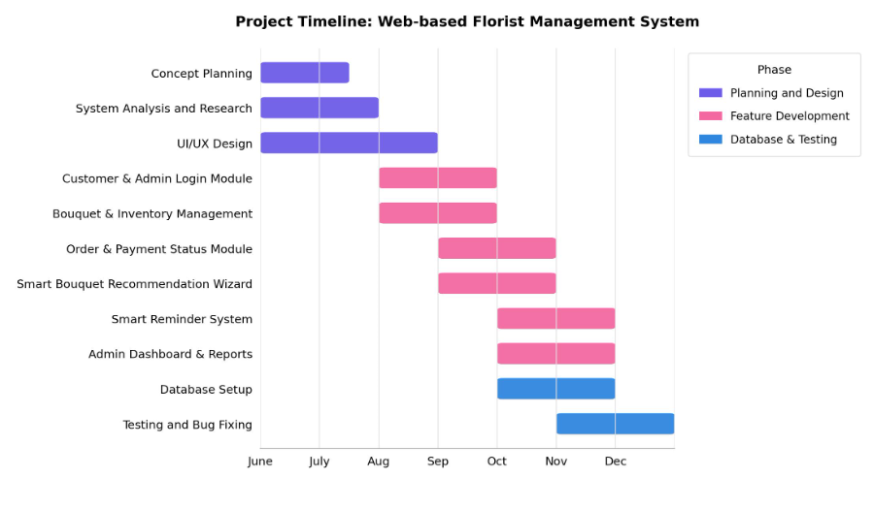
Figure 1.1 project timeline of this system

Planning and Design Phase
- Concept Planning: Starting in early June, this phase aims to define the vision, target users, and core features of the Florist Management System, including the Smart Reminder System and Smart Bouquet Recommendation Wizard.
- System Analysis and Research: Running from June, this involves analyzing the needs of florist business owners and customers, and researching suitable tools and technologies, including PHP Laravel, MySQL, and Bootstrap 5.
- UI/UX Design: Started in June to design a user-friendly interface for both the customer-facing site and the admin dashboard, continuing through August.
Planning and Design + Feature Development
- Concept Planning: Completed by mid-July.
- System Analysis and Research: Completed by the end of July.
- UI/UX Design: Continues running in parallel to refine both customer and admin interface designs, concluding at the end of August.
- Customer & Admin Login Module: Development begins in August, covering registration and authentication for both customers and business owners/admins.
- Bouquet & Inventory Management: Development begins in August, allowing admins to manage bouquet stock, categories, and product listings.
Feature Development
- Customer & Admin Login Module: Development continues through September.
- Bouquet & Inventory Management: Development continues through September.
- Order & Payment Status Module: Development begins in September, supporting order creation, status tracking, and payment status monitoring, running through October.
- Smart Bouquet Recommendation Wizard: Development begins in September, building the preference-based questionnaire that guides customers to suitable bouquets, running through October.
- Smart Reminder System: Development begins in October, implementing automated email notifications for upcoming occasions such as birthdays and anniversaries, running through November.
- Admin Dashboard & Reports: Development begins in October, providing sales insights, customer statistics, and best-selling product data, running through November.
Database & Testing Phase
- Database Setup: Runs from October to November, finalizing the MySQL database structure to support all modules.
- Testing and Bug Fixing: Begins in November and continues through December, covering functional testing, bug resolution, and final refinements before submission.

Chapter 2: Literature Review

2.1 Introduction
The development of web-based management systems has grown significantly over the past decade, driven by the increasing need for businesses to digitalise their operations and improve service delivery. In the context of small and medium enterprises (SMEs), particularly those in the retail and service sectors, web-based systems have proven to be an effective solution for managing daily business activities such as inventory tracking, order processing, and customer relationship management .
The florist industry represents one of the many traditional businesses that still heavily relies on manual and informal methods of operation. Studies in developing countries, including Indonesia and Malaysia, have shown that small retail businesses often face challenges related to unstructured order management, poor inventory visibility, and limited customer engagement strategies. These challenges are consistent with the problems identified in this project, which further justifies the need for a dedicated digital management system for florist businesses.
The emergence of recommendation systems and automated notification features in e-commerce platforms has also been widely discussed in recent literature. Rule-based recommendation approaches, which filter products based on user-defined preferences, have been found to be practical and effective for small-scale e-commerce applications where sufficient historical data for machine learning models may not yet be available. Similarly, automated reminder systems built on scheduled task mechanisms have demonstrated positive effects on customer retention and repeat purchase behaviour in online retail environments.
This chapter reviews three existing systems that are similar in nature to the proposed Florist Management System, analyses their features and limitations, and presents a comparative summary to justify the design decisions made in this project.

2.2 Review on the Existing System

2.2.1 Existing System 1
The first existing system reviewed is Talula Florist, an online florist based in Depok, West Java, offering bouquets, vase arrangements, blooming boxes and baskets in both fresh and preserved flower variants.

Figure 2.1 Homepage of Talula Florist
Figure 2.1 is the homepage view of Talula Florist. There is a scrolling image gallery of featured bouquets and seasonal promotions. If you scroll down, you will see the "2 in 1 Package: Gift & Flower" offer, same-day delivery information, and the brand's story behind the Talula logo.
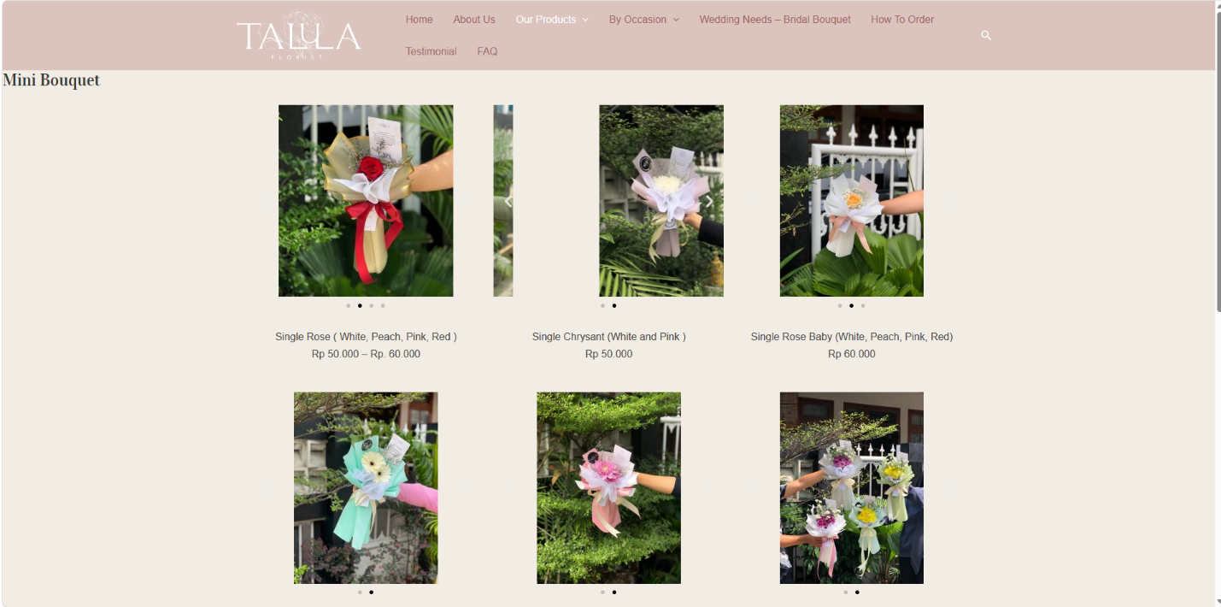
Figure 2.2 Catalog of Talula Florist
Figure 2.2 is a view of the product catalogue in Talula Florist. There are various bouquet categories such as Mini, Small, Medium, and Large Bouquet, as well as an "By Occasion" section for birthdays, anniversaries, and graduations.
Advantages:
a. Extensive Product Categorisation — the "By Occasion" and "By Types" navigation makes it easy for customers to narrow down choices based on their specific need.
b. Same-Day Delivery — the site advertises same-day flower delivery, which builds customer confidence for urgent orders.
c. Brand Identity — the site includes a detailed brand story (the meaning behind the logo and name), which strengthens emotional connection with customers.
Disadvantages:
a. No Visible Real-Time Order Tracking — customers cannot log in to check the status of a placed order; communication after checkout appears to rely on WhatsApp rather than an account dashboard.
b. No Recommendation Support — first-time buyers unsure which bouquet suits their occasion must browse manually through many categories without any guided suggestion tool.
c. No Loyalty or Reminder Feature — there is no mechanism to remind repeat customers of upcoming occasions such as anniversaries or birthdays.

2.2.2 Existing System 2
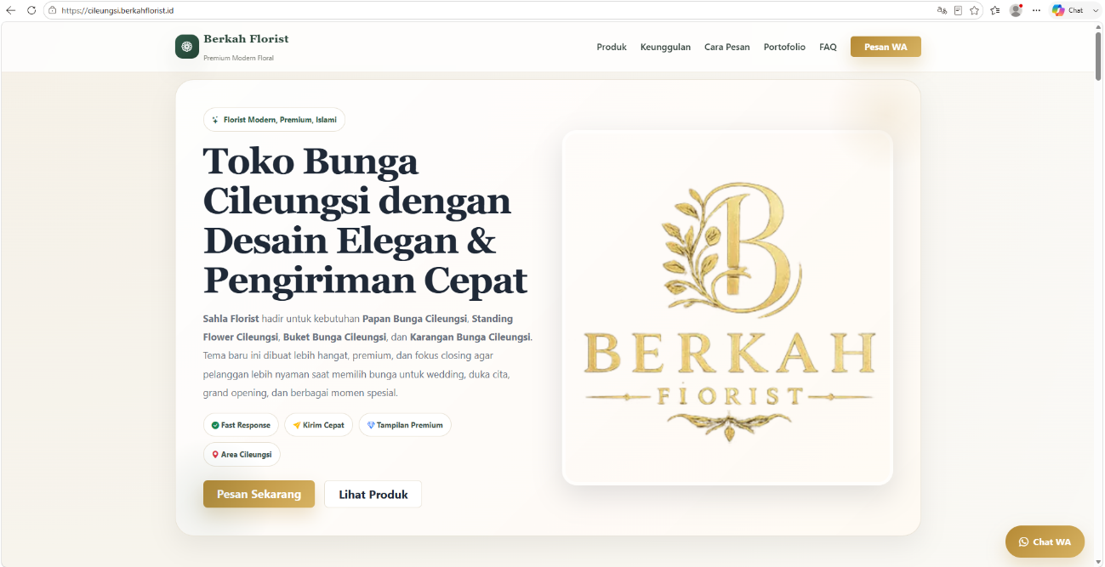
The second existing system reviewed is Berkah Florist (Sahla Florist) Cileungsi, a florist service site targeting the Cileungsi area, specialising in standing flowers, flower boards (papan bunga), wreaths, and bouquets for weddings, condolences, and celebratory events.
Figure 2.3 Homepage of Berkah Florist Cileungsi
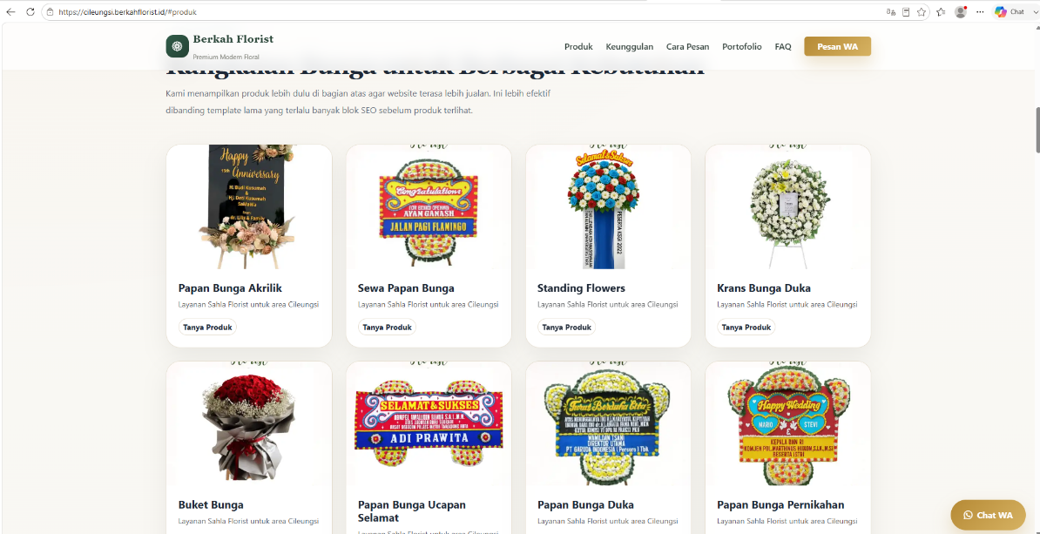
Figure 2.3 is the homepage view of Berkah Florist Cileungsi. There is a hero banner promoting fast response and same-day delivery. If you scroll down, you will see the product showcase section displayed right after the banner, followed by the company's advantages and ordering step
Figure 2.4 Product Catalogue of Berkah Florist Cileungsi
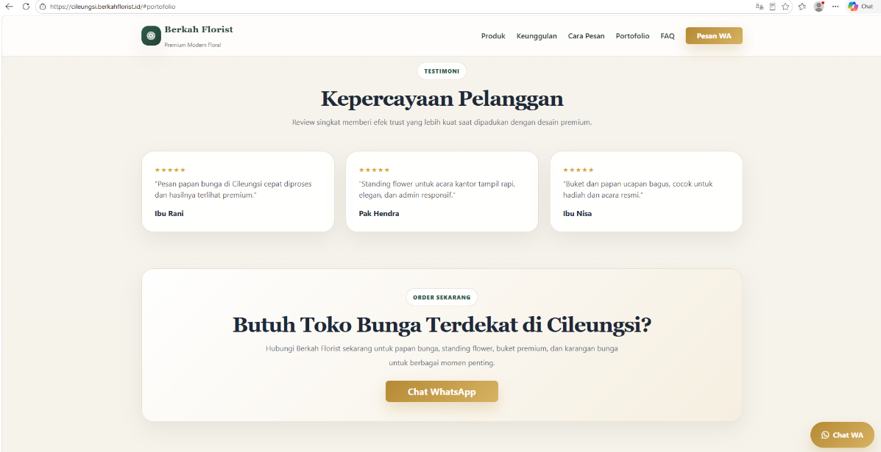
Figure 2.4 is a view of the product catalogue in Berkah Florist Cileungsi. There are various product cards such as Papan Bunga Akrilik, Standing Flowers, Krans Bunga Duka, and Buket Bunga, each with a "Tanya Produk" button linking to WhatsApp.Figure 2.5 is a view of the portfolio section in Berkah Florist Cileungsi. There is a gallery showcasing completed work such as standing flowers, papan bunga, and buket arrangements, along with customer testimonials highlighting fast processing and premium design quality.
Figure 2.5 is a View of FAQ Section of Berkah Florist Cileungsi
Figure 2.5 is a view of the FAQ section in Berkah Florist Cileungsi. There is a list of frequently asked questions covering topics such as custom design requests, same-day ordering, pricing by flower-board size, and delivery coverage area, each answered directly on the page.
Advantages:
a. Fast Order Initiation : every product links directly to a pre-filled WhatsApp message, reducing friction for customers who want to inquire immediately.
b. Clear Ordering Steps : the site outlines a simple four-step process (choose product, send details, processing, delivery) that sets clear expectations for the customer.
c. Wide Service Coverage : the site lists many nearby service areas, showing a broad delivery reach.
Disadvantages:
a. No Online Catalogue Pricing or Cart : prices are not listed per product; customers must ask manually via WhatsApp for every item, which slows down the ordering process compared to a true e-commerce flow.
b. No Customer Account or Order History : the system is essentially a static catalogue with a WhatsApp redirect, offering no login, no order history, and no way to track past purchases.
c. Heavy Reliance on Manual Communication : since all transactions ultimately depend on WhatsApp chat, the business still faces the same manual order-tracking risks (miscommunication, no centralised record) described in Section 1.1.

2.2.3 Existing System 3
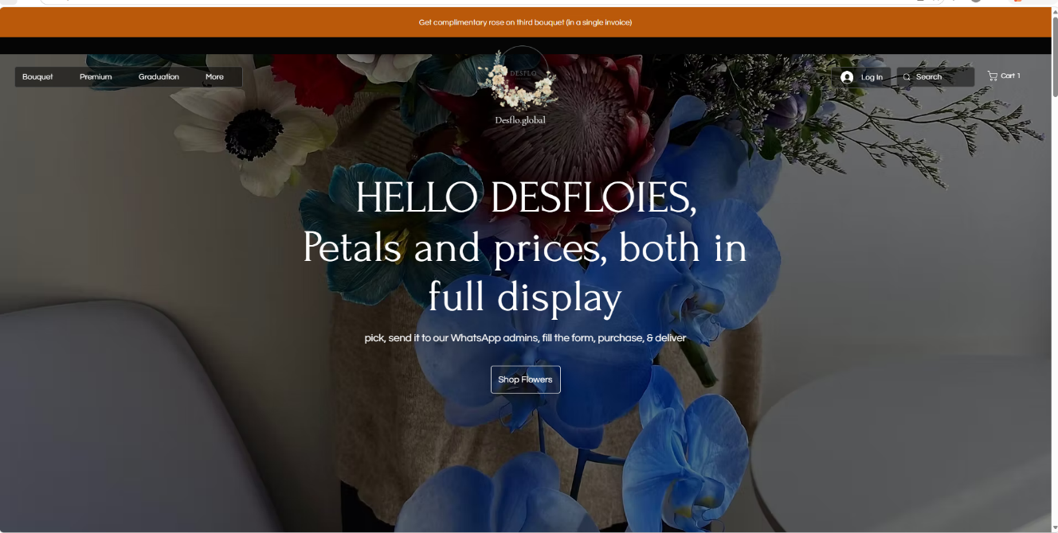
The third existing system reviewed is Desflo, an online florist based in Semanan, Kalideres, Jakarta, founded in 2021 by two young entrepreneurs, offering bouquets, bloom boxes, arrangements, wedding flowers, imported cut flowers (Ecuador rose, Tulip, Ranunculus, Peony, and others), and flower subscriptions.
Figure 2.6 Homepage of Desflo
Figure 2.6 is the homepage view of Desflo. There is a hero banner with the tagline "Petals and prices, both in full display," followed by a client review section featuring testimonials from beauty pageant titleholders, a catalogue preview linking to Bouquet, Bloom Box, and Subscription categories, and a brand story section describing the founders' journey since 2021.

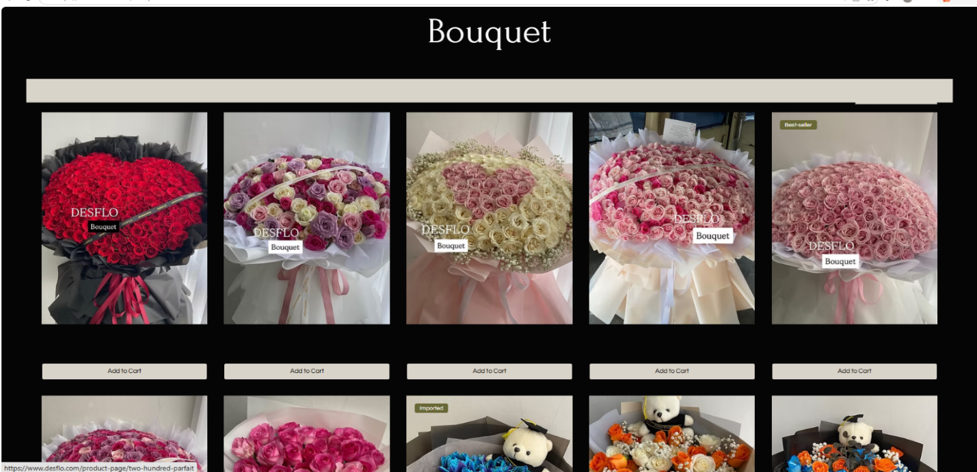
Figure 2.7 is a view of the Shop All page in Desflo. There is a filterable product grid with a price-range slider, and each bouquet — such as Heart of Roses, Cotton Heart, and Whimsy — is displayed with its own price in Rupiah and an "Add to Cart" button, allowing customers to build a cart directly on the site.
Advantages:
a. Genuine Online Cart and Checkout : unlike the previous two systems, Desflo has an actual shopping cart with a checkout page, rather than redirecting every inquiry to WhatsApp.
b. Transparent Per-Item Pricing : every product lists its exact price, including visible discounts on sale items (e.g., regular vs. sale price).
c. Social Proof : the homepage's client review section, featuring recognisable titleholders, builds credibility and trust for new visitors.
Disadvantages:
a. No Integrated Online Payment Gateway : despite having a cart and checkout flow, the site does not process payment directly; customers must manually transfer payment and call to confirm before the order is accepted ("No payment = No order, miss call once, upon transfer"), which reintroduces a manual verification step similar to the WhatsApp-based systems.
b. No Recommendation Support : customers must browse or filter by price manually, with no guided suggestion tool for those unsure what to choose.
c. No Occasion Reminder Feature : there is no mechanism to notify repeat customers ahead of recurring occasions such as anniversaries or birthdays.

2.2.4 Comparison with the Florist Management System
Table 1 presents a comparison between the three existing systems and the proposed Florist Management System.
Feature | Talula Florist | Berkah Florist Cileungsi | Desflo | Florist Management System (Proposed)
Interface UI/UX | Strong | Medium | Strong | Strong
Online Cart/Checkout (in-system) | No (WhatsApp-based) | No (WhatsApp-based) | Yes (cart, no payment gateway) | Yes
Integrated Online Payment | No | No | No (manual transfer + call) | Payment status tracking only
Customer Login & Order History | No | No | Login available, unclear order history | Yes
Product Recommendation | No | No | No | Yes (Smart Bouquet Recommendation Wizard)
Occasion Reminders | No | No | No | Yes (Smart Reminder System)
Admin Sales Dashboard | Not visible to customer | Not visible to customer | Not visible to customer | Yes
Visible Pricing per Item | Yes | No | Yes | Yes
Table 2.1 Comparison Between system

As shown in Table 2.1, all three existing systems fall short in at least one key area compared to the proposed system. Talula Florist and Berkah Florist Cileungsi rely entirely on WhatsApp for ordering, while Desflo goes a step further with a genuine cart and checkout flow but still lacks an integrated payment gateway, requiring manual bank transfer confirmation. None of the three systems offer customers a personalised way to choose a bouquet, nor do any of them remind past customers about upcoming occasions — both gaps directly correspond to the problems identified in Section 1.1. The proposed Florist Management System addresses these gaps by combining a centralised order and inventory platform with two guided digital features, the Smart Bouquet Recommendation Wizard and the Smart Reminder System, while still retaining an admin dashboard for real-time sales and customer insight that none of the three reviewed systems expose.

2.3 Review of Core Technologies & Frameworks (Tech Stack Justification)
Selecting an appropriate technology stack is a critical design decision that affects development speed, maintainability, and long-term scalability of the system. Rather than simply defining each technology, this section compares the selected tools against their common alternatives to justify why they best fit the requirements of the Florist Management System.
a. Backend Framework: PHP Laravel vs. CodeIgniter vs. Node.js (Express)
Criteria | Laravel (PHP) | CodeIgniter (PHP) | Node.js + Express
Built-in ORM | Yes (Eloquent, reduces raw SQL) | No (query builder only) | No (needs separate ORM)
Built-in MVC structure | Yes, enforced | Loosely enforced | Not enforced
Task scheduling (Reminder System) | Yes, built-in Scheduler | No, needs external cron | Needs external library
Learning curve (single dev) | Moderate, well-documented | Low | Moderate–High (async)
Package ecosystem | Large (Composer) | Smaller | Large but fragmented
Table 2.2 Comparison of Backend Framework Alternatives
Laravel was selected because its built-in Task Scheduler directly supports the Smart Reminder System's requirement to run automated, occasion-based notification checks without external cron configuration (Author, Year). Its Eloquent ORM also reduces the risk of SQL injection compared to writing raw queries, addressing the security requirement identified in Chapter 3. CodeIgniter, while lighter-weight, lacks a native scheduler and requires more manual boilerplate for these recurring tasks. Node.js/Express offers strong real-time capabilities but was considered unnecessary overhead for a system that does not require live/streaming features, and its asynchronous programming model presents a steeper learning curve for a single-developer project with a fixed timeline (Section 1.6).
b. Database: MySQL vs. PostgreSQL vs. MongoDB
Criteria | MySQL | PostgreSQL | MongoDB
Data structure fit | Relational, strong for structured entities | Relational, stronger for complex/JSON hybrid | Document-based, flexible schema
Relationship handling (ERD Fig. 3.9) | Strong (foreign keys, joins) | Strong | Weak (manual referencing)
Native Laravel support | Excellent (default driver) | Excellent | Needs additional package
Best suited for | Transactional apps, fixed schema | Complex analytical queries | Unstructured/rapidly-changing data
Table 2.3 Comparison of Database Alternatives
The Florist Management System's data — customers, orders, order items, bouquets, categories, reminders — is inherently relational, as reflected in the ERD in Figure 3.9, where entities are linked through clearly defined one-to-many relationships. MySQL was chosen over MongoDB because the system's data does not benefit from a flexible, schema-less document structure; instead, it requires consistent relational integrity (e.g., an order must always reference a valid customer and bouquet). MySQL was chosen over PostgreSQL for practical reasons: it is the default, most widely supported database driver in Laravel hosting environments, and the system does not require PostgreSQL's advanced analytical query features, which would be unnecessary complexity for this project's scope (Author, Year).
c. Frontend: Bootstrap 5 vs. Tailwind CSS vs. Plain CSS
Criteria | Bootstrap 5 | Tailwind CSS | Plain CSS
Development speed | Fast (pre-built components) | Moderate (utility classes) | Slow (everything custom)
Responsive design support | Built-in grid & breakpoints | Built-in utility breakpoints | Manual
Learning curve (limited time) | Low | Moderate | N/A
Design flexibility | Moderate (can look templated) | High | Highest but time-costly
Table 2.4 Comparison of Frontend Framework Alternatives
Bootstrap 5 was selected primarily for development speed, given the project's single-developer resourcing and fixed 7-month timeline (Section 1.6). Its pre-built responsive grid system directly satisfies the Non-Functional Requirement for responsive design across desktop and mobile devices (Section 3.1.2), without requiring the additional configuration time that Tailwind CSS's utility-first approach demands. While Tailwind offers more visual flexibility, this advantage was judged less important than shipping a functional MVP within the available timeframe.

2.4 Review of Relevant Algorithms or Architectural Patterns
a. Architectural Pattern: Model-View-Controller (MVC)
The system adopts the Model-View-Controller (MVC) architectural pattern, which is natively enforced by Laravel. MVC separates the application into three components: the Model (handles data logic and database interaction via Eloquent), the View (handles presentation, rendered with Blade templates), and the Controller (handles request logic and coordinates between Model and View). This separation of concerns is particularly relevant for a system with two distinct user roles — customer and admin — each requiring different views and controllers but sharing the same underlying data models (e.g., the Bouquet model is read by both the customer catalogue and the admin management form). MVC was preferred over a monolithic script-based structure (common in raw PHP) because it improves maintainability and testability, both of which are necessary given the project's Testing & Evaluation phase (Section 3.1).
b. Recommendation Algorithm: Rule-Based Filtering vs. Collaborative Filtering vs. Content-Based ML
Criteria | Rule-Based Filtering | Collaborative Filtering (ML) | Content-Based ML
Data requirement | None (works from day one) | Needs large historical interaction data | Needs substantial labeled data
Implementation complexity | Low | High | High
Suitability for new system | Strong fit | Poor fit (cold-start problem) | Poor fit
Explainability to user | High (clear logic) | Low (black box) | Moderate
Table 2.5 Comparison of Recommendation Approach Alternatives
The Smart Bouquet Recommendation Wizard uses a rule-based filtering approach, where customer inputs (occasion, budget, colour, style) are matched against structured bouquet attributes to produce a scored list of suggestions (as described in the recommendations → recommendation_results relationship in Figure 3.9). This approach was chosen over collaborative filtering because collaborative filtering depends on historical interaction data from many users — a "cold-start problem" that a newly launched system does not yet have (Author, Year). Content-based machine learning models similarly require a training dataset that does not yet exist for this business. A rule-based approach is therefore both practically necessary and appropriate at this stage, while remaining a system that could later be upgraded to a learning-based model once sufficient transaction data has been collected.
c. Reminder Mechanism: Scheduled Task Pattern
The Smart Reminder System is implemented using a scheduled task (cron-based) pattern, in which a recurring background process checks customer occasion dates (e.g., birthdays, anniversaries) stored in the customers table and triggers a notification when a date falls within a defined threshold. This pattern was selected over a manually-triggered or real-time push-based approach because reminders are inherently time-based rather than event-based, making a scheduled check the natural architectural fit; Laravel's built-in Task Scheduler (compared in Section 2.3a) directly supports this without requiring a separate message-queue infrastructure.

2.5 Summary & Synthesis (The Research Gap)
The review of three existing florist systems in Section 2.2 revealed a consistent set of gaps: none of the reviewed systems (Talula Florist, Berkah Florist Cileungsi, Desflo) offer customer account-based order tracking combined with guided, preference-based bouquet selection, and none provide any form of automated occasion reminder — despite these being common pain points identified in Section 1.1. The technology stack reviewed in Section 2.3 was selected specifically to close these gaps within practical constraints: Laravel's built-in scheduler and MVC structure directly enable the reminder and dual-role (customer/admin) requirements, while MySQL's relational model supports the structured order-inventory-customer relationships the existing WhatsApp-based systems lack entirely. The architectural and algorithmic choices in Section 2.4 — MVC for maintainable separation of customer/admin concerns, and rule-based filtering for the Recommendation Wizard — were chosen because they are appropriate for a system with no existing historical data, unlike machine-learning alternatives that would be infeasible at launch.
Taken together, the literature and existing-system review confirms a clear research gap: existing florist platforms in the reviewed market segment provide either manual WhatsApp-based ordering (Talula, Berkah) or a basic e-commerce cart without guidance or retention features (Desflo), but none combine centralised order management, a guided recommendation tool, and automated customer re-engagement in a single system. The proposed Florist Management System is designed specifically to fill this gap, using a technology stack and architectural approach justified above as both technically sound and feasible within the project's single-developer, 7-month timeline.

Chapter 3

SYSTEM ANALYSIS

3.1 Introduction
The preceding chapters established both the problem context and the market gap that justify this project: Chapter 1 identified the operational challenges faced by manually run florist businesses, while Chapter 2 demonstrated, through a comparative review of three existing florist platforms, that none of them offer guided product discovery or occasion-based customer engagement. This chapter shifts the discussion from why the system is needed to how it will be systematically analysed and specified.
System analysis is the stage in which the problems and feature gaps identified earlier are translated into a structured, verifiable definition of what the system must do and how it will be built. To achieve this, several system development methodologies were considered for managing the Florist Management System's development lifecycle; the methodology selected, along with the justification for that choice, is discussed in Section 3.2. This chapter also presents an internal strengths-and-weaknesses assessment of the proposed system through a SWOT Analysis, defines the system's scope in terms of user interface, functional and non-functional requirements, and constraints and assumptions, and outlines the system models used to represent the structure and behaviour of the Florist Management System.

3.1.1 Purpose
The purpose of this chapter is to present the system analysis for the Florist Management System, translating the problems and objectives identified in Chapter 1, together with the feature gaps found in the existing systems reviewed in Chapter 2, into a concrete and verifiable specification that will guide the design work in Chapter 4. This chapter presents an internal strengths-and-weaknesses assessment of the proposed system (SWOT Analysis), the defined scope of the system (user interface, functional requirements, non-functional requirements, and constraints and assumptions), the system development process, and the system models used to represent the structure and behaviour of the system.

3.1.2 SWOT Analysis
A SWOT analysis was conducted on the proposed Florist Management System itself — rather than on a competing business — to evaluate its internal strengths and weaknesses alongside external opportunities and threats. This analysis draws on the problems identified in Chapter 1 and the comparative review of existing systems in Chapter 2 (Section 2.2) to justify why the system’s two “smart” features are positioned as its key differentiators.
STRENGTHS | WEAKNESSES
- Two differentiating features not found in the three existing systems reviewed in Section 2.2: the Smart Bouquet Recommendation Wizard and the Smart Reminder System.  - Centralised, real-time inventory tracking directly addresses the overselling/stockout problem identified in Section 1.1.2.  - Built on a well-documented, widely supported stack (Laravel, MySQL, Bootstrap 5) that fits a single-developer academic timeline. | - No online payment gateway integration; payment must still be confirmed manually by the Admin, so the payment step is only partially automated.  - The rule-based recommendation engine may become less accurate as the bouquet catalogue grows large, compared to a machine-learning-based approach.  - Single-developer academic scope limits testing depth; no formal multi-user User Acceptance Testing (UAT) is planned.
OPPORTUNITIES | THREATS
- Growing digitalisation trend among SMEs in the florist/retail sector in Indonesia and Malaysia (Section 2.1) creates market readiness for adoption.  - The Smart Reminder System could later be extended with WhatsApp API notifications for wider customer reach.  - Recommendation Wizard usage data could eventually feed a machine-learning-based recommendation upgrade. | - Existing competitors reviewed in Section 2.2 (e.g., Talula Florist, Berkah Florist Cileungsi) could add similar recommendation or reminder features.  - Customers' habitual reliance on WhatsApp ordering may slow adoption of a new self-service platform.  - Manual payment confirmation may feel slower and less trustworthy to customers than competitors offering instant online payment.

3.1.3 Scope
The scope of the Florist Management System covers the user interface, the functional requirements, the non-functional requirements, and the constraints and assumptions under which the system is developed, as detailed in the following sub-sections.

3.1.3.1 User Interface
The Florist Management System provides two main portals:
- Customer Portal: allows customers to register and log in, browse and search the bouquet catalogue, use the Smart Bouquet Recommendation Wizard, manage their cart, check out and track orders, and submit testimonials.
- Admin Portal: enables the business owner and system administrator to manage bouquet inventory and categories, update order and payment status, manage customer records and reminders, and view the sales and customer dashboard and reports.

3.1.3.2 Functional Requirements
Table 3.1 consolidates the functional requirements of the system into a single reference list.
Table 3.1 Functional Requirements
ID | Functional Requirement | Description (Input → Process → Output)
FR-01 | User Registration | Input: name, email, phone, password. Process: validate and store customer data. Output: registration success/failure message; redirect to login on success.
FR-02 | User Login | Input: email, password. Process: validate credentials against stored records. Output: redirect to customer dashboard on success; error message on failure.
FR-03 | Browse & Search Bouquet Catalogue | Input: category selection, search/filter keywords. Process: retrieve matching bouquet records from the database. Output: bouquet listing with images, prices, and stock availability.
FR-04 | Cart Management | Input: add/update/remove cart item. Process: check stock and update cart contents. Output: updated cart summary with items and subtotal.
FR-05 | Checkout & Place Order | Input: delivery details, occasion, selected cart items. Process: save order record, decrement bouquet stock. Output: order confirmation with order number.
FR-06 | Use Recommendation Wizard | Input: occasion, preferred colour, budget, style, size. Process: match preferences against bouquet attributes and score results. Output: a list of recommended bouquets.
FR-07 | Track / Cancel Order | Input: order number, track/cancel request. Process: read or update order status. Output: current order status or cancellation confirmation.
FR-08 | Receive Reminder | Input: scheduled occasion date (from customer profile). Process: check due reminders and generate a notification. Output: reminder notification delivered to the customer.
FR-09 | Submit Testimonial | Input: testimonial content, rating. Process: store testimonial pending admin approval. Output: submission confirmation.
FR-10 | Manage Bouquet, Category & Stock (Admin) | Input: bouquet/category data (add, edit, delete), stock updates. Process: save changes to the bouquet and category database. Output: updated catalogue reflected on the customer side.
FR-11 | Manage Order, Payment Status & Customer (Admin) | Input: order status update, payment status update, customer management action. Process: update order/payment records or customer records. Output: updated order list and customer records.
FR-12 | View Dashboard & Reports (Admin) | Input: dashboard/sales/customer report request. Process: read and aggregate order, sales, and customer data. Output: dashboard summary, sales report, or customer report.

3.1.3.3 Non-Functional Requirements
Table 3.2 defines the non-functional requirements of the system with measurable, verifiable criteria, rather than general statements, so that each requirement can be tested during the testing stage (Section 3.2.4).
Table 3.2 Non-Functional Requirements
ID | Category | Measurable Criteria
NFR-01 | Security | Passwords are hashed using bcrypt; role-based access control (Customer vs Admin) is enforced through Laravel middleware, so only authenticated Admin accounts can access management and dashboard routes.
NFR-02 | Performance | The bouquet catalogue and admin dashboard pages must load within 3 seconds on a standard broadband connection (≥ 10 Mbps) for a catalogue of up to 200 bouquet listings.
NFR-03 | Scalability | The system must support at least 50 concurrent users browsing or ordering without significant performance degradation, and the database schema must accommodate up to 5,000 order records without requiring structural change.
NFR-04 | Reliability / Availability | The deployed test environment targets 99% uptime during operating hours (excluding scheduled maintenance); stock validation prevents duplicate decrement when two customers checkout the same bouquet concurrently.
NFR-05 | Usability | The interface follows a responsive Bootstrap 5 layout, verified on screen widths from 360px (mobile) to 1920px (desktop); core actions (browse → add to cart → checkout) must be completable within 3 main steps.
NFR-06 | Maintainability | The system follows the MVC architectural pattern so that each module (e.g., Recommendation Wizard, Reminder System) can be updated or extended independently without modifying unrelated modules.

3.1.3.4 Constraints and Assumptions
Constraints:
- The system is accessible via web browser only; no dedicated mobile application is developed.
- No third-party online payment gateway is integrated; payment status must be confirmed manually by the Admin based on proof of payment (e.g., bank transfer receipt).
- The system is designed for a single-branch, single-admin business model; multi-branch or multi-tenant support is outside the current scope.
- A stable internet connection is required for both customer and admin access, as the system is fully web-based.
- The project is developed within a single-developer academic timeline (Section 1.6), which limits testing to functional and manual testing rather than large-scale load or performance testing.
Assumptions:
- The florist business has at least one staff member acting as Admin who is available to confirm payments and update order status in a timely manner.
- Customers possess basic digital literacy sufficient to operate a web-based ordering system without additional training.
- Bouquet stock data entered by the Admin is accurate and updated promptly, since the system relies on this data to prevent overselling.
- Email is a reliable and commonly checked communication channel for customers, as it is the medium used by the Smart Reminder System.
- A rule-based scoring approach is sufficient for the Recommendation Wizard without requiring historical data for machine learning, consistent with the literature reviewed in Section 2.4.

3.2 System Development Process
In developing the Florist Management System, several system development methodologies were considered, including the Waterfall Model, Rapid Application Development (RAD), and Agile Methodology. After evaluating the nature of this project — which involves multiple interdependent modules such as customer ordering, bouquet inventory management, the Smart Bouquet Recommendation Wizard, and the Smart Reminder System — Agile Methodology was selected as the most suitable approach.
Agile was chosen because it supports iterative development, allowing each module to be built, tested, and refined independently before full integration, rather than requiring the entire system to be specified upfront. This is particularly useful for the two “smart” features of this project, which may need several rounds of refinement before they behave as intended, and for a single-developer academic timeline where minor requirement changes are expected as development progresses.
The system development process for the Florist Management System follows the Agile cycle of planning, design, development, testing, deployment, and maintenance, repeated across short iterations (sprints). Each sprint delivers one functional component of the system — for example, one sprint may focus solely on customer registration and login, while another focuses on bouquet inventory management. This iterative structure was chosen over a single-pass Waterfall approach because it allows problems to be identified early: if the Smart Bouquet Recommendation Wizard’s filtering logic does not produce useful suggestions during testing, it can be revised in the next sprint without reworking the entire system. Agile also supports the phased plan already set out in the project timeline (Section 1.6), where feature modules are developed in overlapping stages rather than strictly one after another.
Development is organised into the following planned builds:
- Build 1 — Core Platform: Customer and admin authentication, bouquet and category management
- Build 2 — Transaction Features: Cart management, checkout, order placement, order and payment status tracking
- Build 3 — Smart Features: Smart Bouquet Recommendation Wizard, Smart Reminder System
- Build 4 — Admin Insights: Admin dashboard, sales report, customer report, testimonial approval
Each build is reviewed against its functional requirements before the next begins, ensuring that foundational modules — such as the bouquet catalogue — are stable before dependent features, such as the recommendation engine that reads from that catalogue, are developed. The following sub-sections describe the six stages of this process in detail.

3.2.1 Requirement Gathering
Requirements were gathered through a structured review of existing florist systems (Chapter 2) and analysis of manual florist operations, rather than through formal end-user interviews, given the single-developer academic scope of this project. This technique was chosen because reviewing live, comparable systems provided concrete, verifiable feature gaps (e.g., the absence of recommendation or reminder tools) that directly justified the system’s two “smart” features, grounding requirements in evidence rather than assumption. The detailed outcome of this stage is presented in Section 3.1.3 (Scope).

3.2.2 System Design
A Use Case Diagram, Context Diagram, DFD Levels 0–1, and an Entity Relationship Diagram (ERD) were used to model the system at the analysis level (Section 3.3). These techniques were selected specifically because the system has two distinct user roles (Customer and Admin) with largely separate workflows — the Use Case and Context Diagrams establish who interacts with the system and what they can do, while the DFDs trace how data such as order details, bouquet stock, and reminder schedules move between processes and data stores. The ERD was developed last, once data flow was clear, to finalise the relational structure linking customers, orders, bouquets, and reminders. UI mockups were also designed separately for the customer-facing catalogue/checkout flow and the admin dashboard, reflecting the fact that customers need a browsing-and-purchasing experience while admins need a data-management experience; the detailed design-level models and design forms are presented in Chapter 4.

3.2.3 Implementation
The system is implemented using PHP Laravel as the backend framework, MySQL as the database, and Bootstrap 5 for the frontend, following the MVC (Model-View-Controller) architectural pattern. This approach was chosen specifically because MVC separates the Recommendation Wizard’s filtering logic (Controller) from the underlying bouquet data (Model) and the customer-facing question flow (View), allowing the recommendation rules to be adjusted independently without touching how bouquet data is stored or displayed. Laravel’s built-in task scheduler is used as the core mechanism behind the Smart Reminder System, allowing reminder emails to be triggered automatically on a defined schedule rather than requiring manual admin action.

3.2.4 Testing
Manual functional testing is performed on each module individually as it is completed (e.g., testing the Recommendation Wizard’s scoring logic against sample preference inputs), followed by integration testing once modules are combined, to confirm that data created in one module (e.g., an order) is correctly reflected in dependent modules (e.g., the admin dashboard’s sales report).

3.2.5 Deployment
The system is deployed to a local/test server for cross-browser and cross-device verification prior to final submission, ensuring the responsive Bootstrap layout behaves consistently across common screen sizes.

3.2.6 Maintenance
After deployment, the system enters a maintenance phase covering corrective maintenance — fixing bugs discovered after submission or during the project demonstration — and minor perfective maintenance, such as adjusting the Recommendation Wizard’s scoring weights or refining the Reminder System’s email templates based on feedback received during evaluation. Because this is a single-developer academic project, formal long-term maintenance (e.g., service-level-agreement-based support) is outside the scope of this proposal. However, the modular MVC architecture described in Section 3.2.3 is designed so that future enhancements — such as adding an online payment gateway, which is currently outside the system scope (Section 3.1.3) — can be incorporated without major rework of the existing modules.

3.3 System Modeling
The system modelling process is conducted to provide a comprehensive visual representation of the proposed Web-Based Florist Management System. These models are developed to illustrate the overall system architecture, user interactions, business processes, data relationships, and navigation flow before the implementation stage begins. By modelling the system in advance, both the functional and non-functional requirements identified during the system analysis phase can be translated into a structured and well-organised system design.
The system models developed for the proposed Florist Management System include:
- Use Case Diagram
- Context Diagram (DFD Level 0)
- Data Flow Diagram (DFD Level 1)
- System Flowcharts (Customer & Admin)
- Entity Relationship Diagram (ERD)
- Site Map
- Screen Flow
These modelling techniques provide a clear blueprint for the development of the system by describing how customers and administrators interact with the application, how information flows throughout the system, and how the database entities are related. Furthermore, the models serve as a reference throughout the implementation, testing, and maintenance phases, ensuring that the developed system fulfils the project objectives and functional requirements defined in the earlier chapters.

CHAPTER 4

SYSTEM DESIGN

4.1 Introduction
The Florist Management System is a web-based florist ordering and management platform designed to simplify how customers browse, purchase, and track bouquet orders, while giving the business owner centralised control over inventory and sales. The system includes several essential forms that form the core of the user interaction process, from registration and login to bouquet browsing, guided recommendations, checkout, and admin-side order management. Each form is designed with a simple and intuitive interface, ensuring ease of use for both first-time and repeat customers.
The registration and login forms serve as the initial gateway for users to access the system. The registration form contains fields such as full name, email address, phone number, password, and date of birth, while the login form requires only an email address and password. After successfully logging in, customers can access the bouquet catalogue, where they may browse by category or use the Smart Bouquet Recommendation Wizard to receive guided suggestions based on occasion, budget, and colour preference. Selected bouquets are automatically saved in the cart and carried forward to checkout, where customers enter delivery details and complete their order.
Furthermore, the Florist Management System also provides a dedicated admin form responsible for managing bouquet inventory, order and payment status, and customer records. This admin form includes more complex features such as adding or editing bouquet listings, monitoring stock levels, and viewing sales and customer reports through a centralised dashboard. With this complete system structure, the Florist Management System is able to provide a convenient, guided, and efficient bouquet ordering experience, both for customers and the business owner.
Chapter 4 presents the detailed system design for the web-based Florist Management System. While system analysis (Chapter 3) focused on identifying requirements and business process workflows, this chapter translates those analytical requirements into concrete software design specifications.
Purpose: The purpose of this design phase is to provide a technical blueprint for the system's architecture, structural database relationships, behavioral interactions, and front-end interface layouts. This ensures that the system components—such as the Smart Bouquet Recommendation Wizard, Smart Reminder System, and Admin Management Dashboard—are seamlessly integrated before full implementation.
Scope: The design scope encompasses structural and behavioural UML modelling — Use Case, Sequence, Activity, State Machine, Class, Component, and Deployment Diagrams — as well as web site mapping and user interface screen flows/wireframes covering both the Customer and Admin portals.

4.2 Design Forms and Report

4.2.1 Site Map
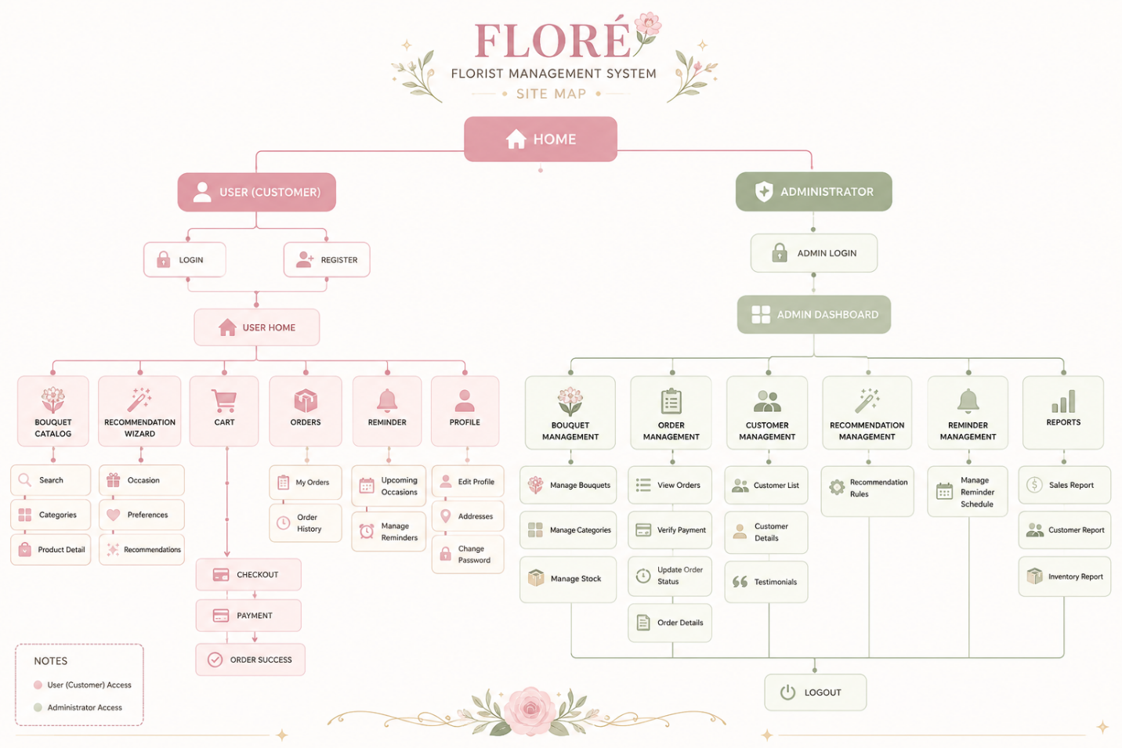
The Site Map defines the overall navigational hierarchy and structural organization of the Florist Management System web application. It illustrates how pages are connected across the public front-end customer portal and the restricted back-end admin dashboard.

4.2.2 UML Diagrams
Unified Modeling Language (UML) diagrams are used to model the static structure and dynamic behavioral aspects of the system.

4.2.2.1 Use Case Diagram
The Use Case Diagram defines the functional scope of the application by illustrating interactions between primary actors (Customer, Admin) and external support actors (Reminder Scheduler, Email Service/WhatsApp API).
- Diagram Reference:
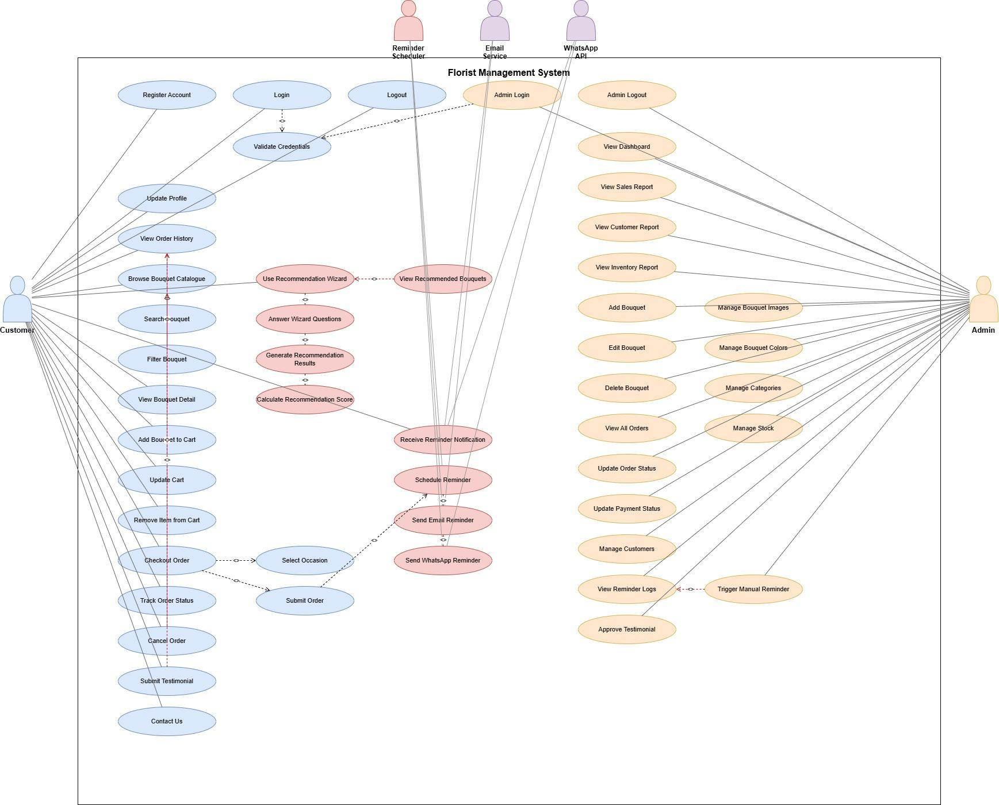
- Figure 4.2 USE CASE DIAGRAM
Figure 4.2 presents the Use Case Diagram of the Florist Management System, showing the two primary actors — Customer and Admin — along with two supporting external actors, the Reminder Scheduler and the Email Service/WhatsApp API, which the system relies on to deliver notifications. The Customer's use cases include Register Account, Login, Browse Bouquet Catalogue, Search Bouquet, Filter Bouquet, Add Bouquet to Cart, Checkout Order, Use Recommendation Wizard, Track Order Status, Cancel Order, and Submit Testimonial. The Admin's use cases include Manage Bouquet, Manage Categories, Manage Stock, View All Orders, Update Order Status, Manage Customers, and View Sales/Customer/Inventory Reports. Several relationships use <<include>>, such as Checkout Order always including Validate Credentials, and <<extend>>, such as Use Recommendation Wizard optionally extending into Generate Recommendation Results.
Description: Customers interact with use cases such as Register Account, Browse Catalogue, Use Recommendation Wizard, Add to Cart, Checkout Order, Track Order, and Submit Testimonial. Admins interact with use cases like Manage Bouquet, Manage Categories, Manage Stock, Update Order Status, and View Sales/Customer Reports. Included (<<include>>) relationships enforce authentication during checkout, while extended (<<extend>>) relationships link the wizard to recommendation results.

4.2.2.2 Sequence Diagram
The Sequence Diagram models the chronological, step-by-step messaging and object interactions during key system transactions, such as the customer checkout and recommendation execution flows.
- Diagram Reference:
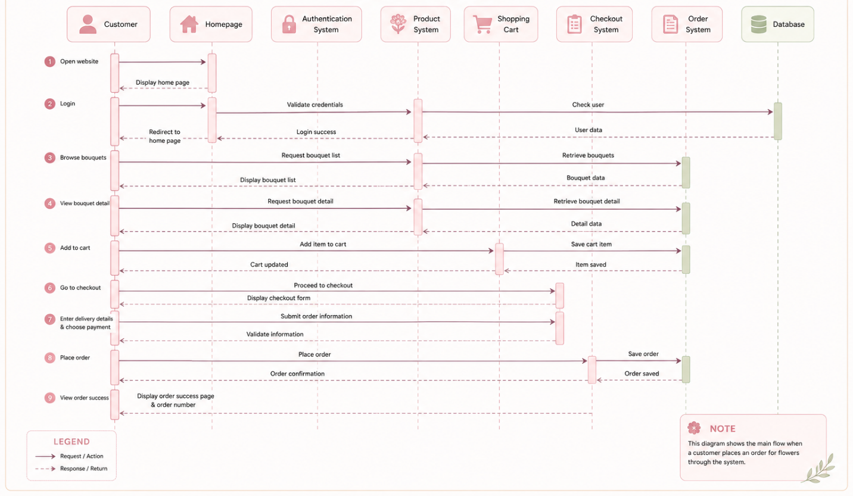
Description: Illustrates how the Customer sends input data through the UI / Order Interface, which passes requests to the Order Controller, validates stock with the Bouquet Model, saves order records in the MySQL Database, and returns an order confirmation response.

4.2.2.3 Activity Diagram
The Activity Diagram maps out the operational workflow and decision logic within system processes, including parallel actions and conditional branches.
- Diagram Reference:
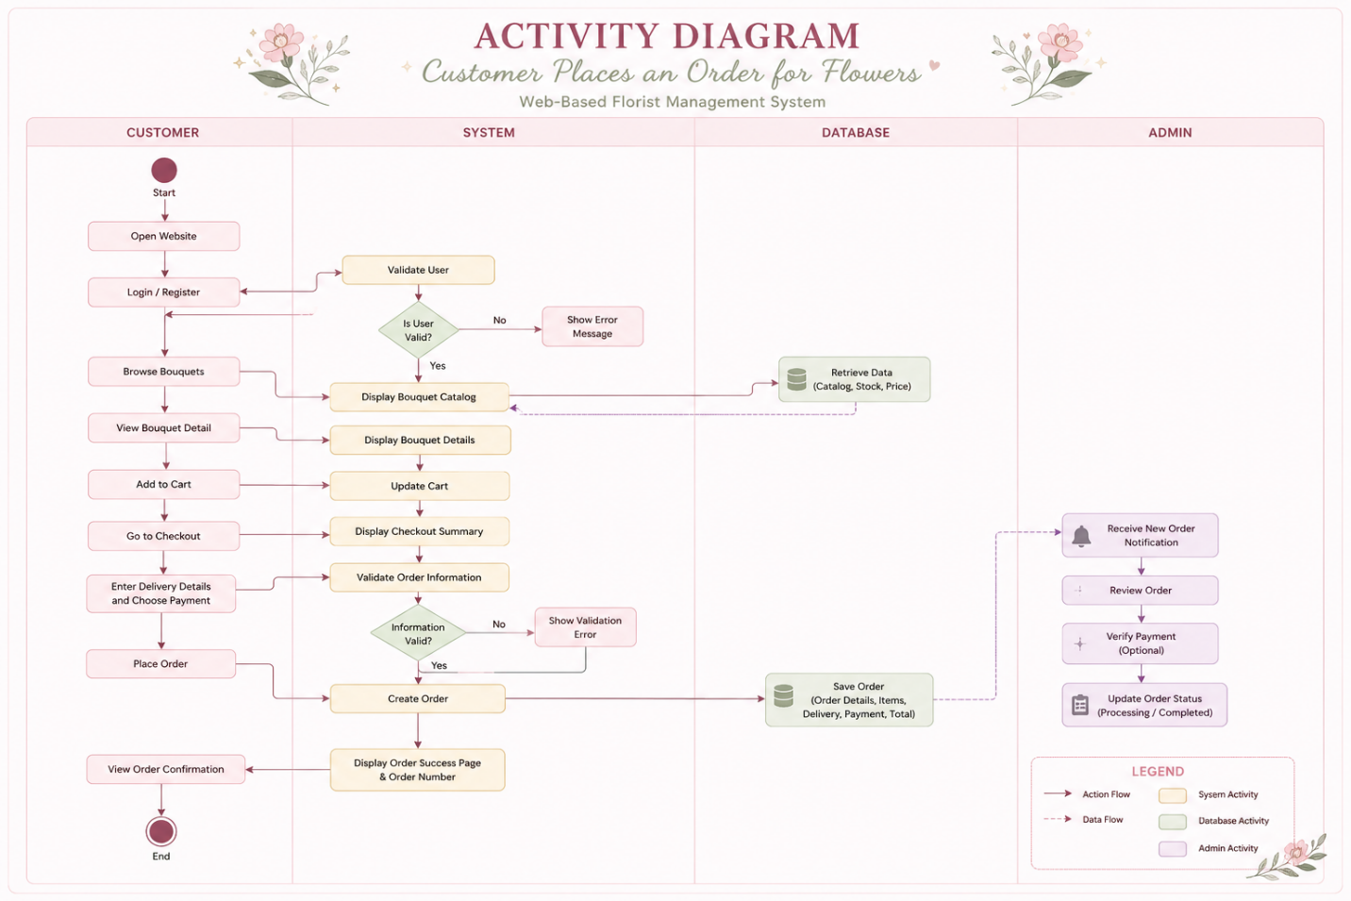
Description: Represents the workflow from the moment a user initiates a task (e.g., answering preference questions in the Smart Recommendation Wizard). It displays logic branches (e.g., verifying stock levels or checking if payment proof is uploaded) and parallel paths (e.g., saving order data while triggering an occasion reminder notification).

4.2.2.4 Class Diagram
The Class Diagram forms the structural blueprint of the system's data model, detailing object classes, attributes, methods/operations, and relationship multiplicities.
- Diagram Reference:
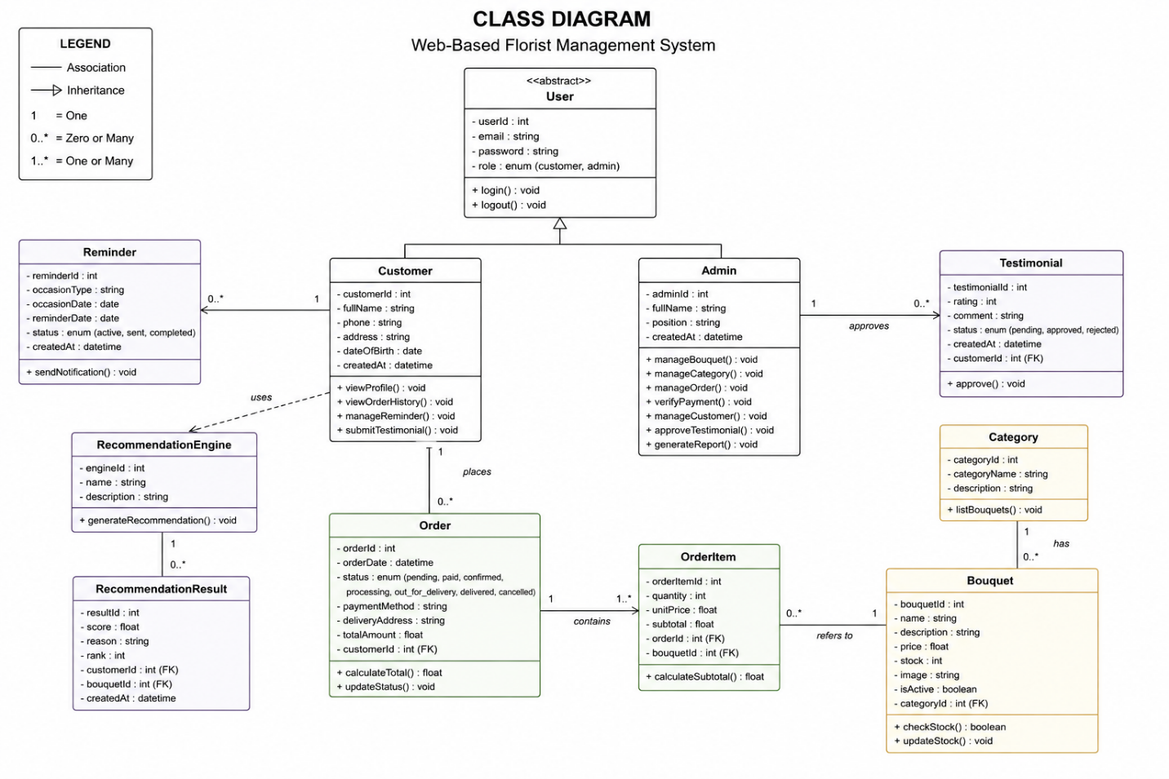
Description: Captures domain entities including User, Customer, Admin, Bouquet, Category, Order, OrderItem, Payment, Recommendation, and Reminder. Multiplicities depict that a Customer can place multiple (1..*) Orders, while each Order contains one or more OrderItems linked to specific Bouquets.

4.2.2.5 State Machine Diagram
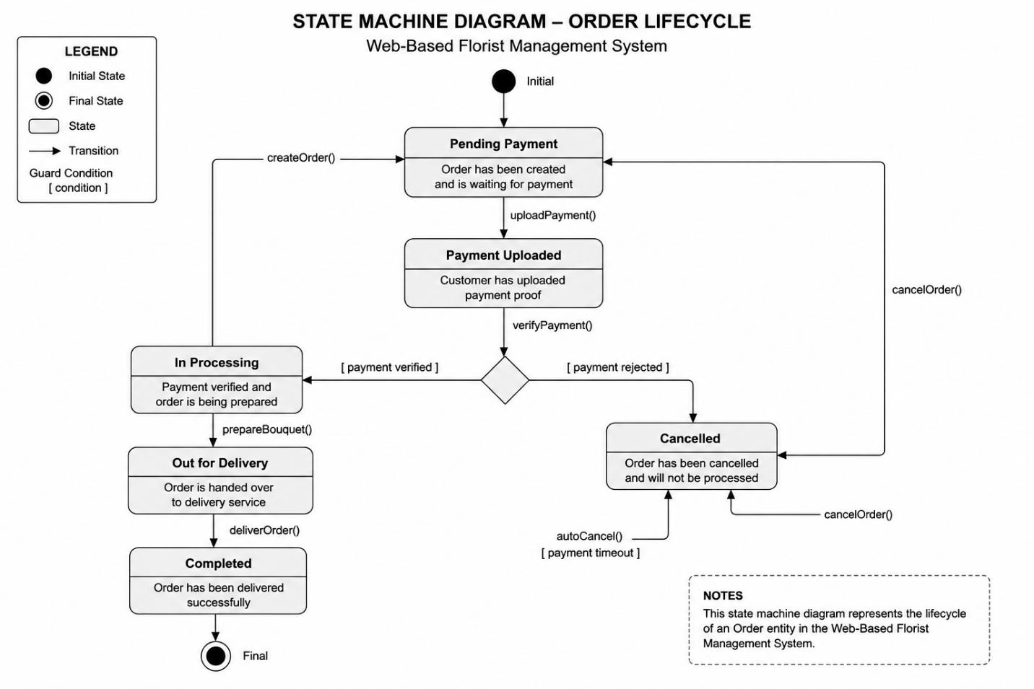
Description: Illustrates the dynamic lifecycle and valid state transitions of the system's core entities. Specifically, it tracks an Order object as it transitions through the following states: Created, when the customer first submits a checkout request; Pending Payment, while the system awaits proof of payment from the customer; Payment Confirmed, once the Admin has verified the submitted payment; Preparing, during which the bouquet is assembled by the florist; Out for Delivery, once the order leaves for the customer's delivery address; and finally Delivered, marking successful completion of the order. An order in the Pending Payment state may also transition directly to Cancelled if payment is not verified within the expected timeframe or if the customer cancels the request, preventing an unconfirmed order from proceeding further into the fulfilment process. It also models the lifecycle of customizable bouquet items and payment status verifications.

4.2.2.6 Component Diagram
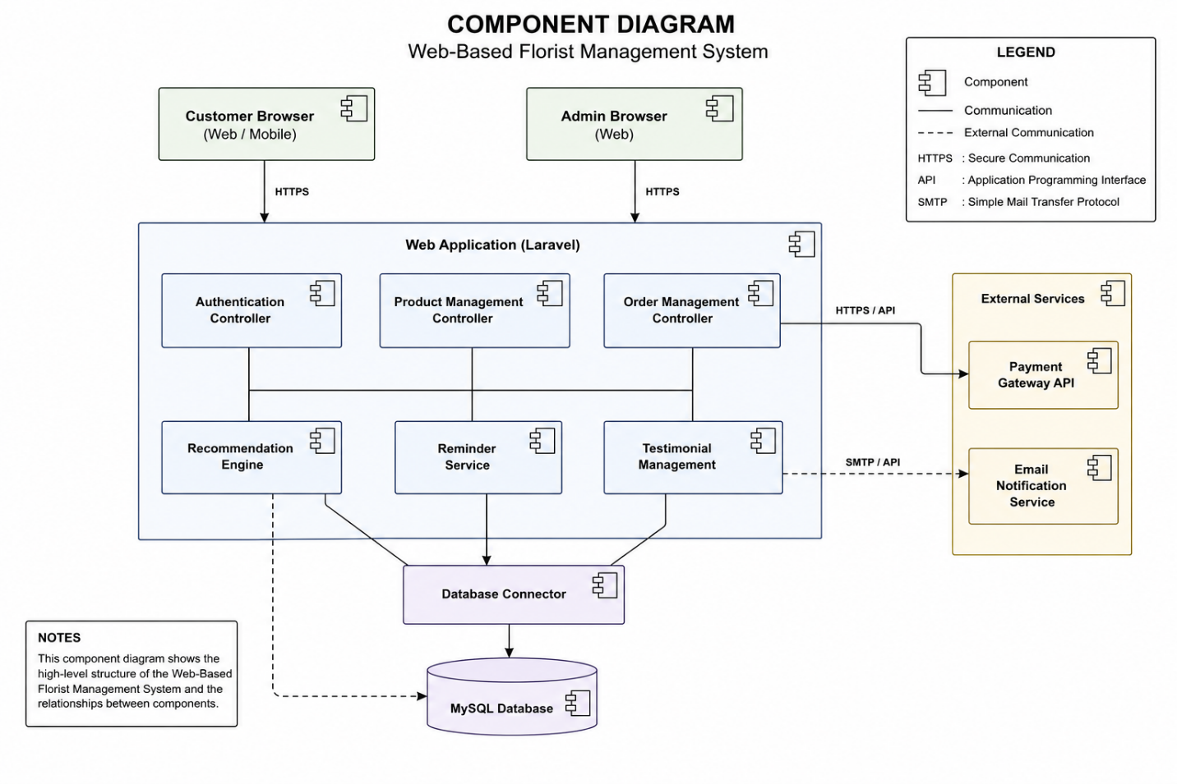

Description: High-level view of the structural organization of software components (UI Component, Authentication Controller, Recommendation Engine, Database Connector, External Payment/Messaging Gateway).

4.2.2.7 Deployment Diagram
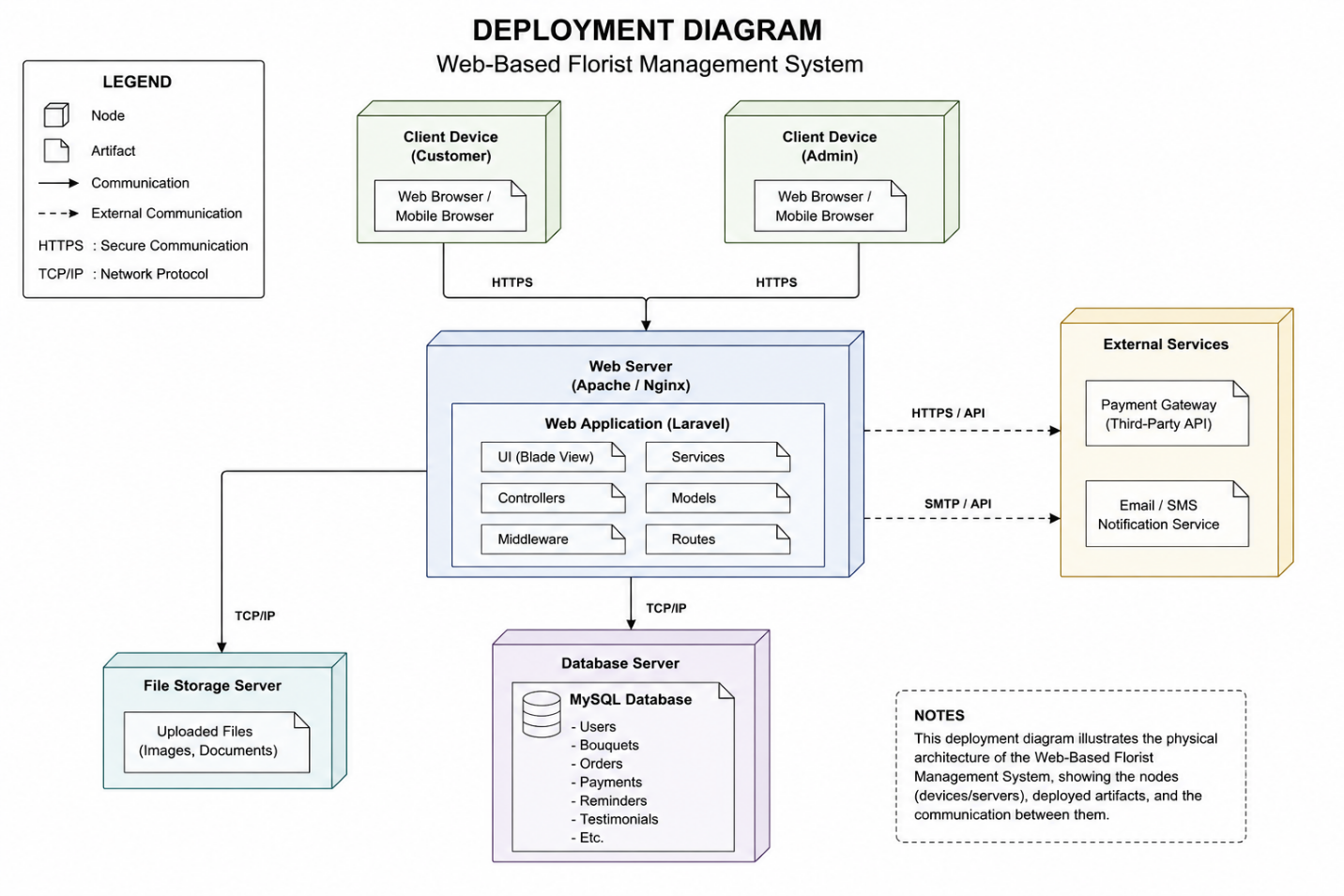

Description: Maps out the physical execution environment, showing how web application components, database servers (MySQL), and client browsers interact over network protocols (HTTPS/APIs).
4.2.2.8 ERD
4.2.2.9 CONTEXT DIAGRAM

4.2.3 Screen Flow / User Interface
The User Interface (UI) design outlines the visual wireframes, screen flow, and form layouts for both the Customer and Admin interfaces.
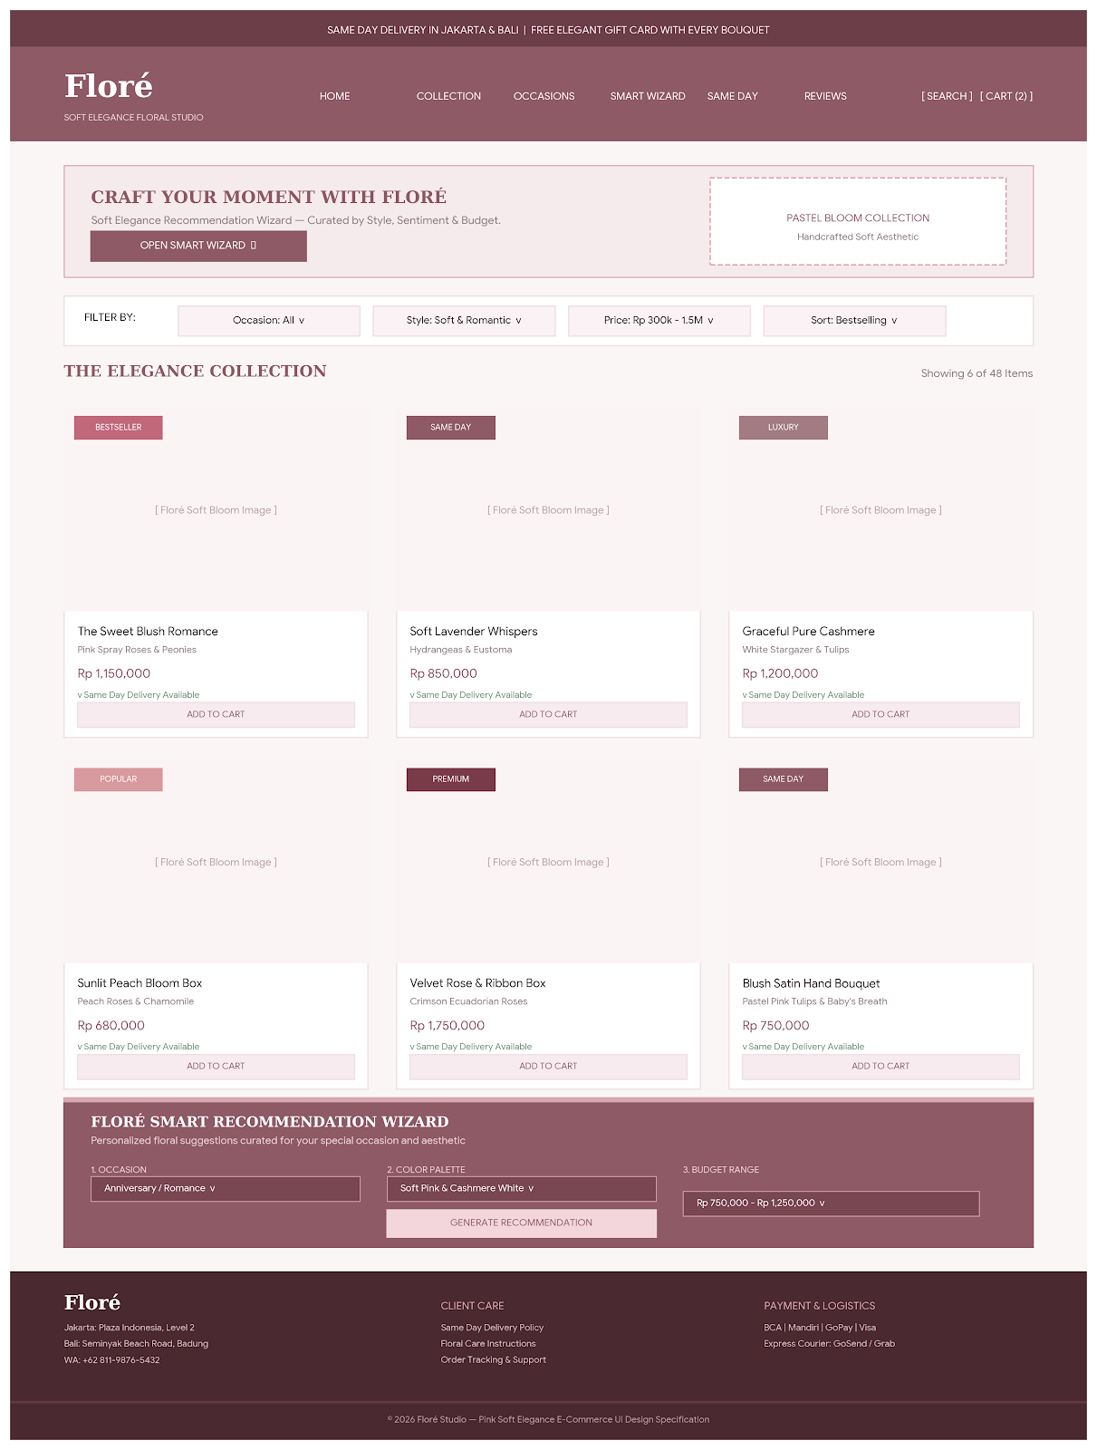
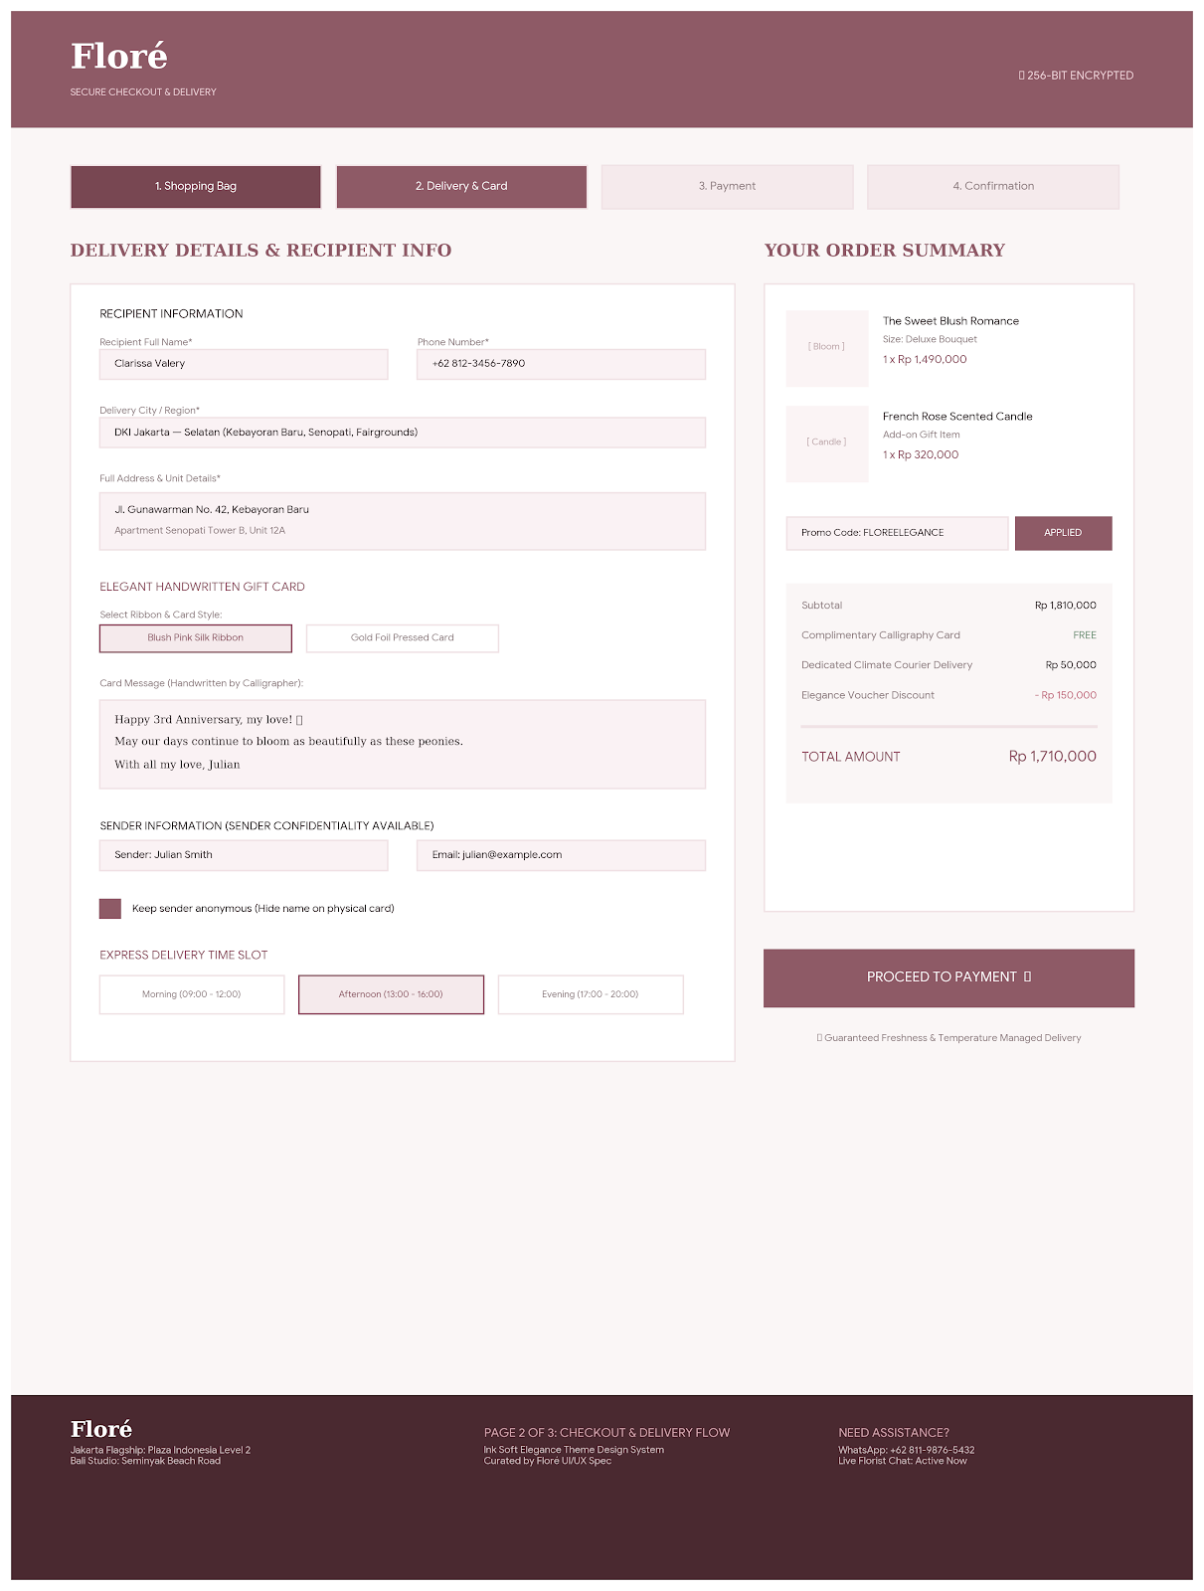
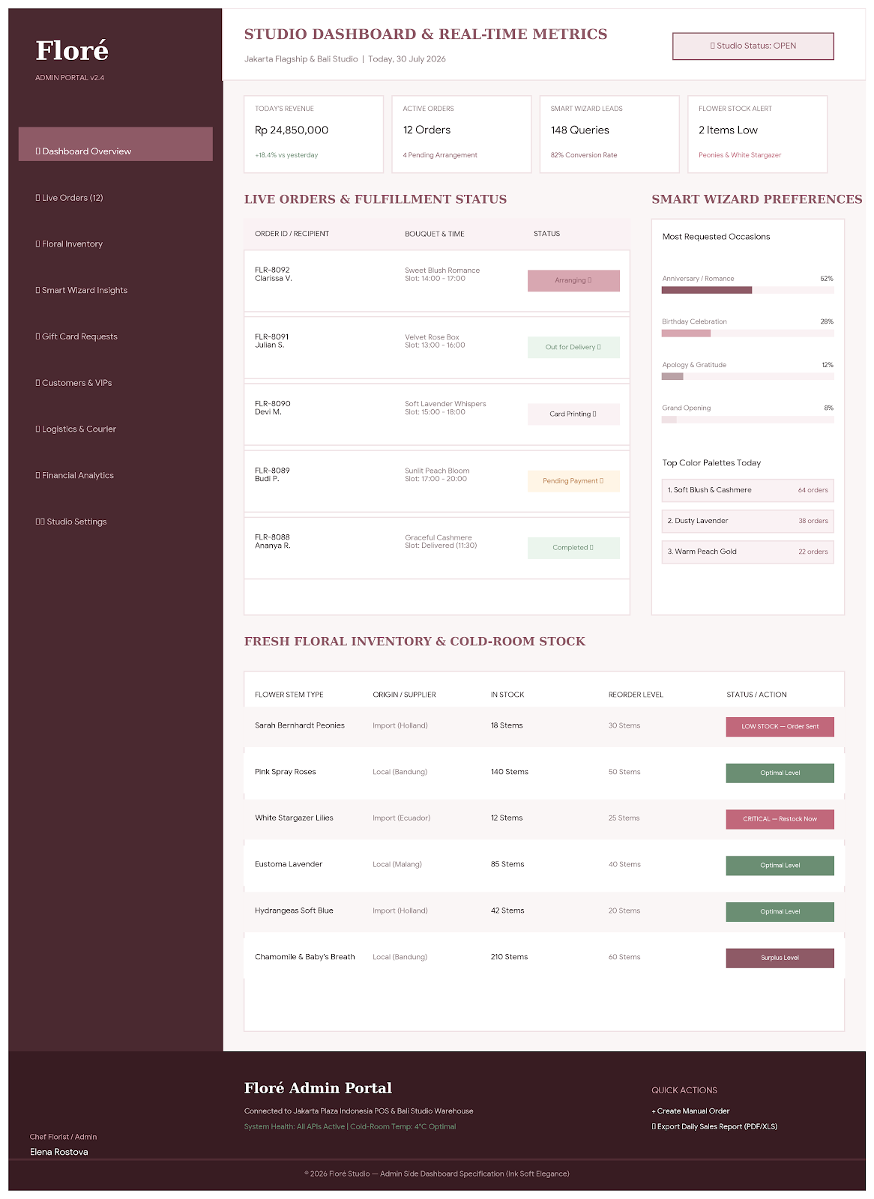
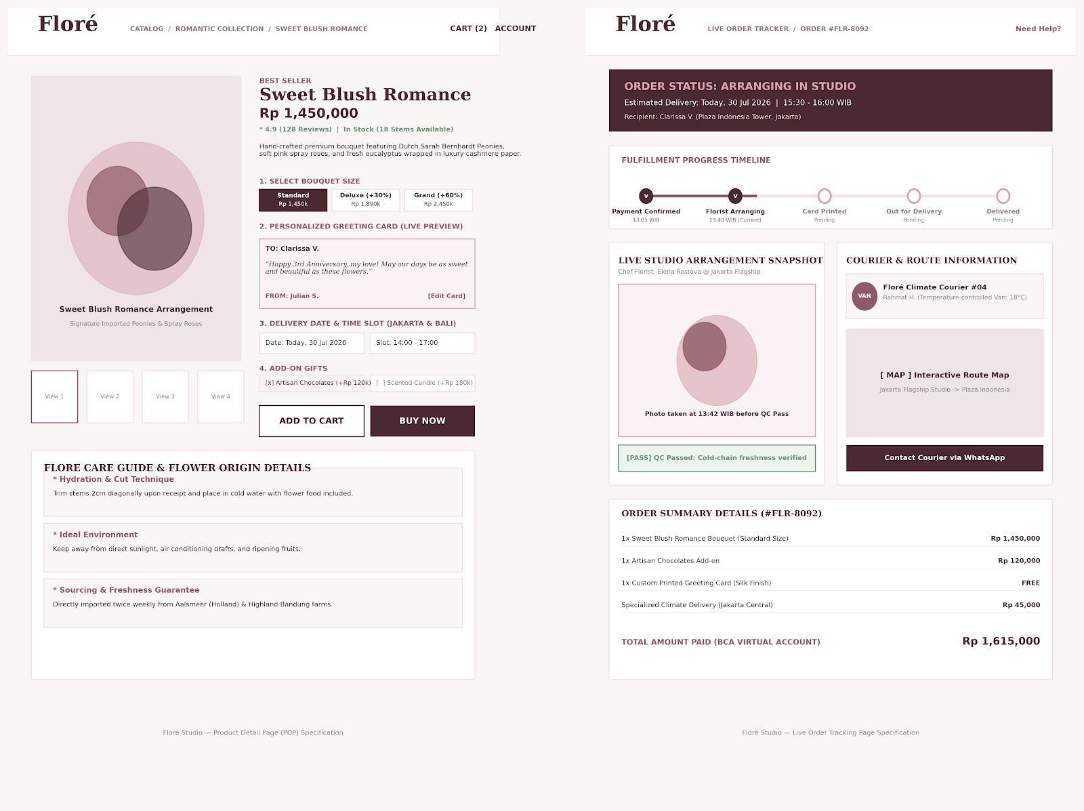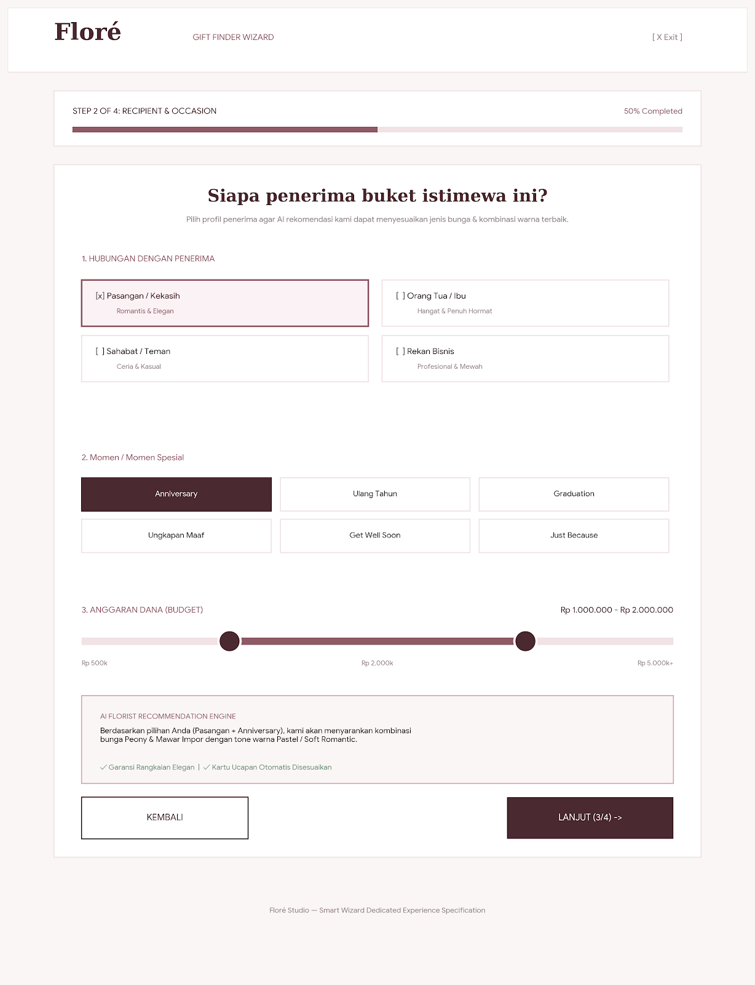
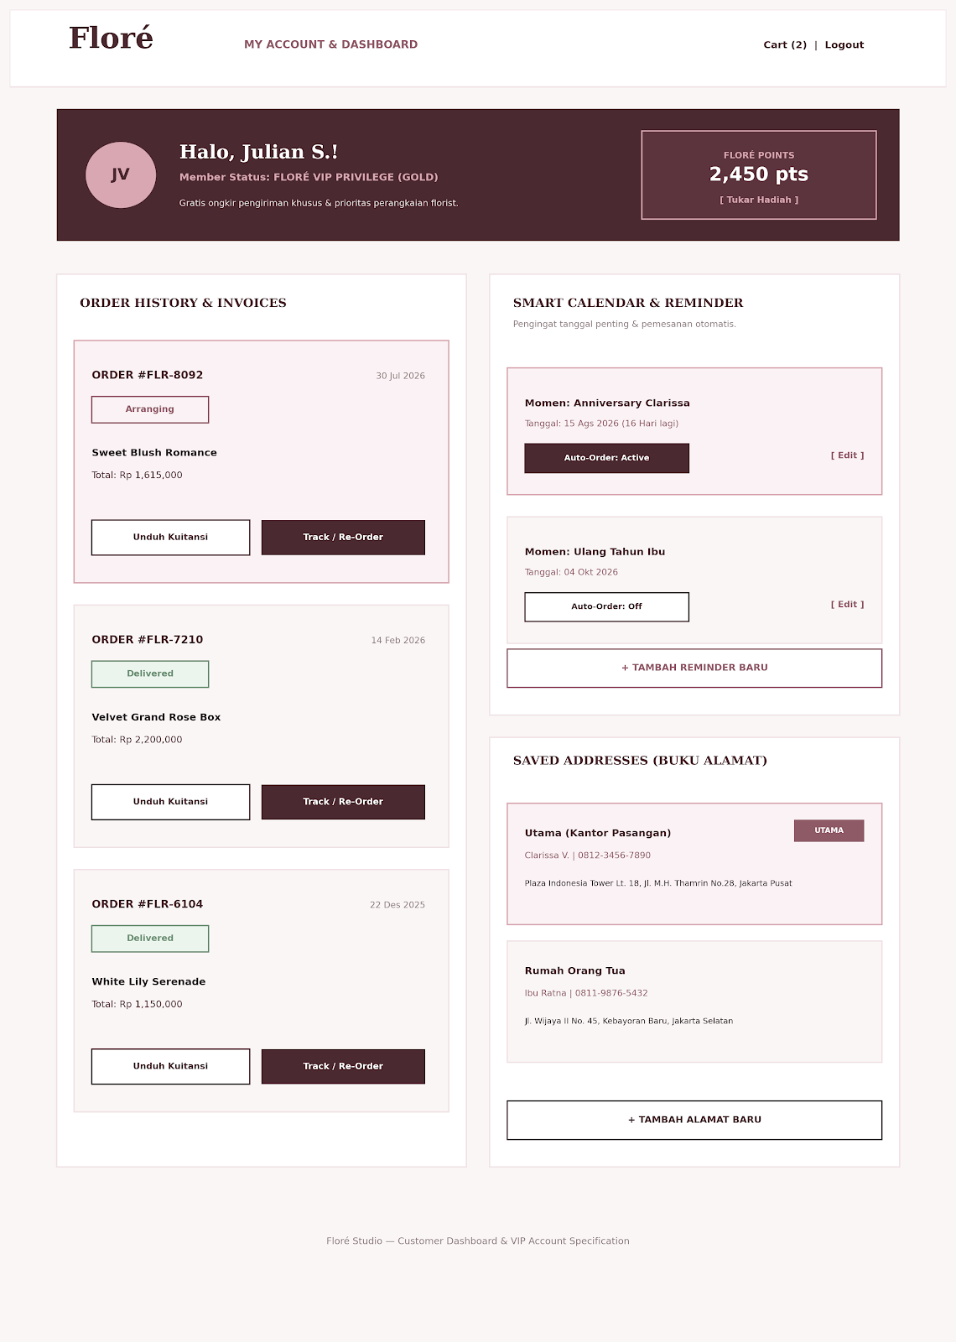
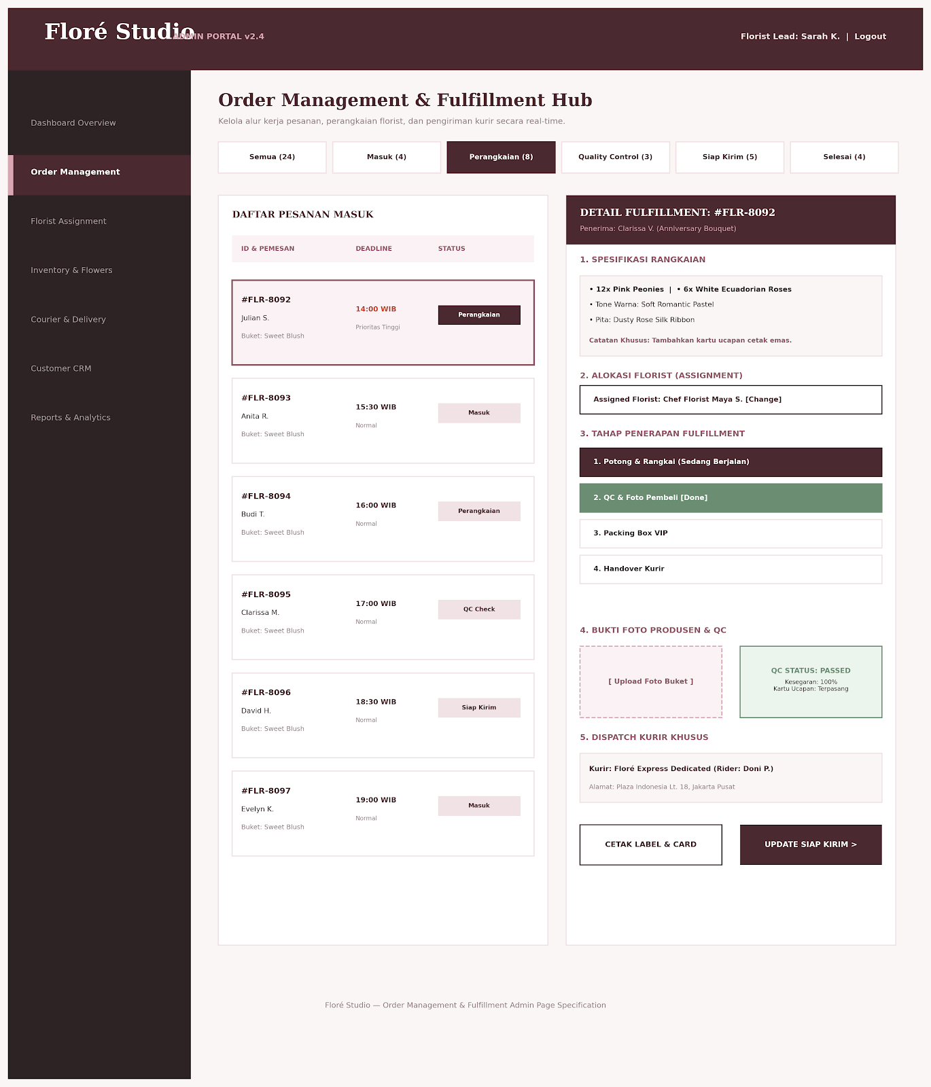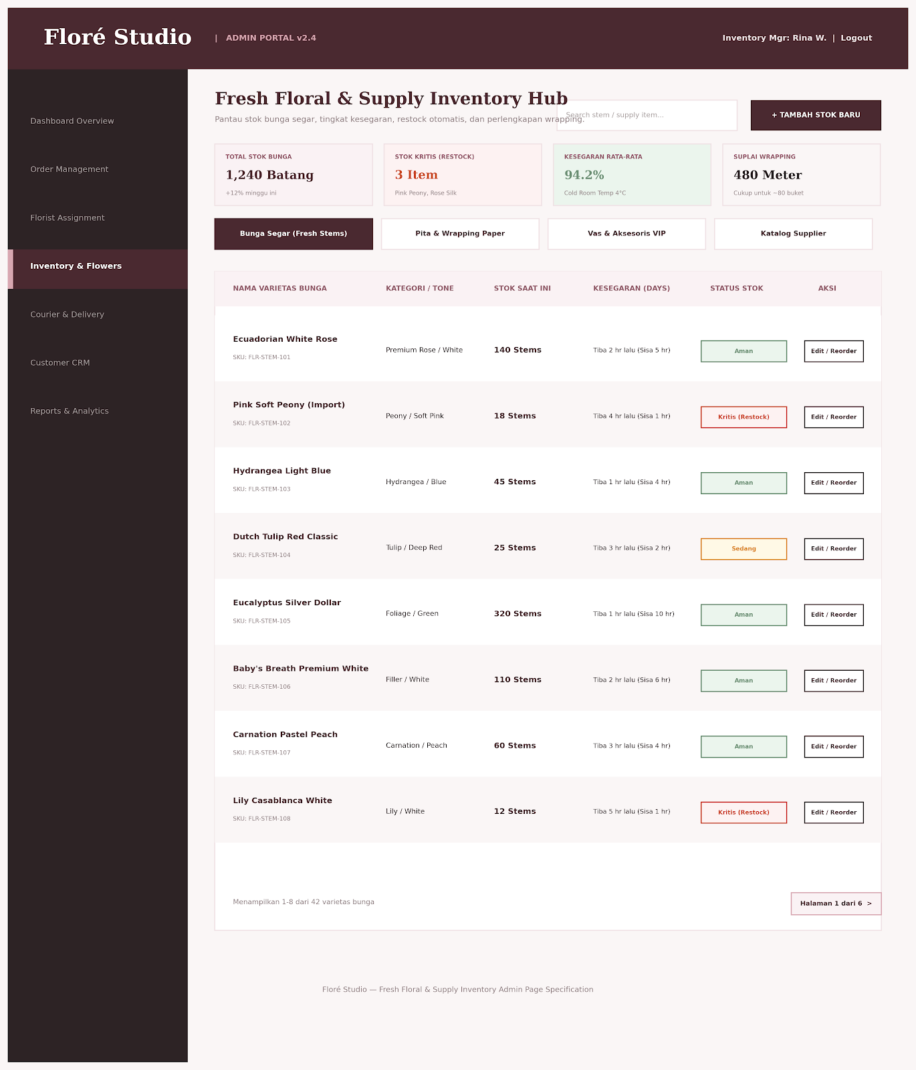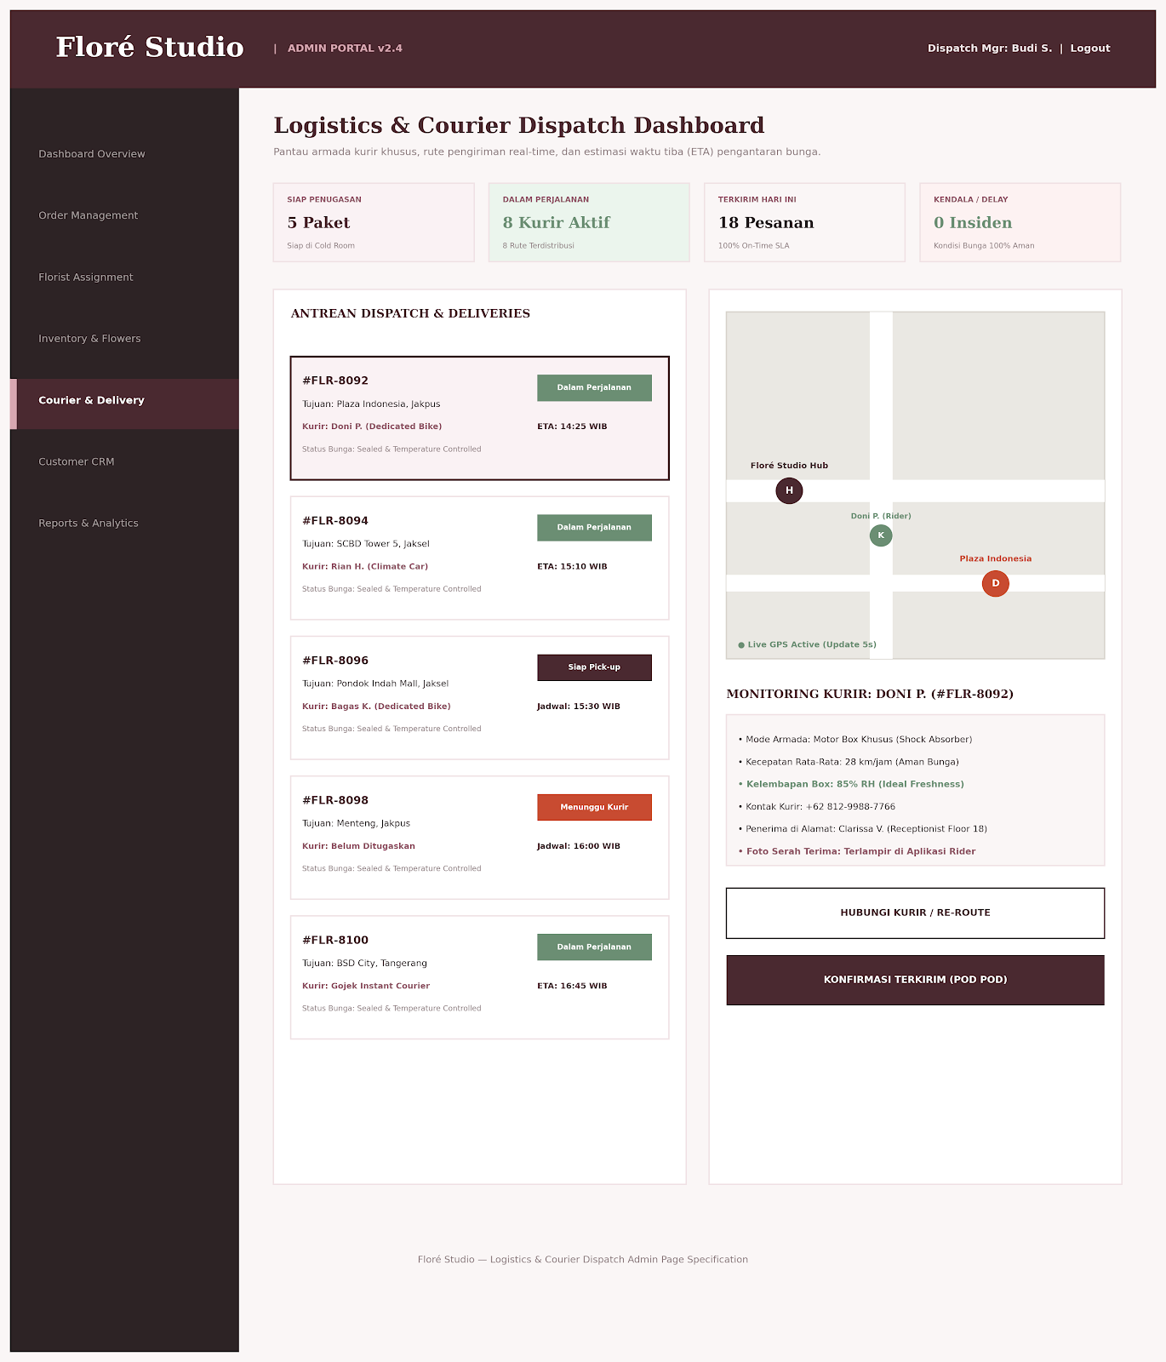
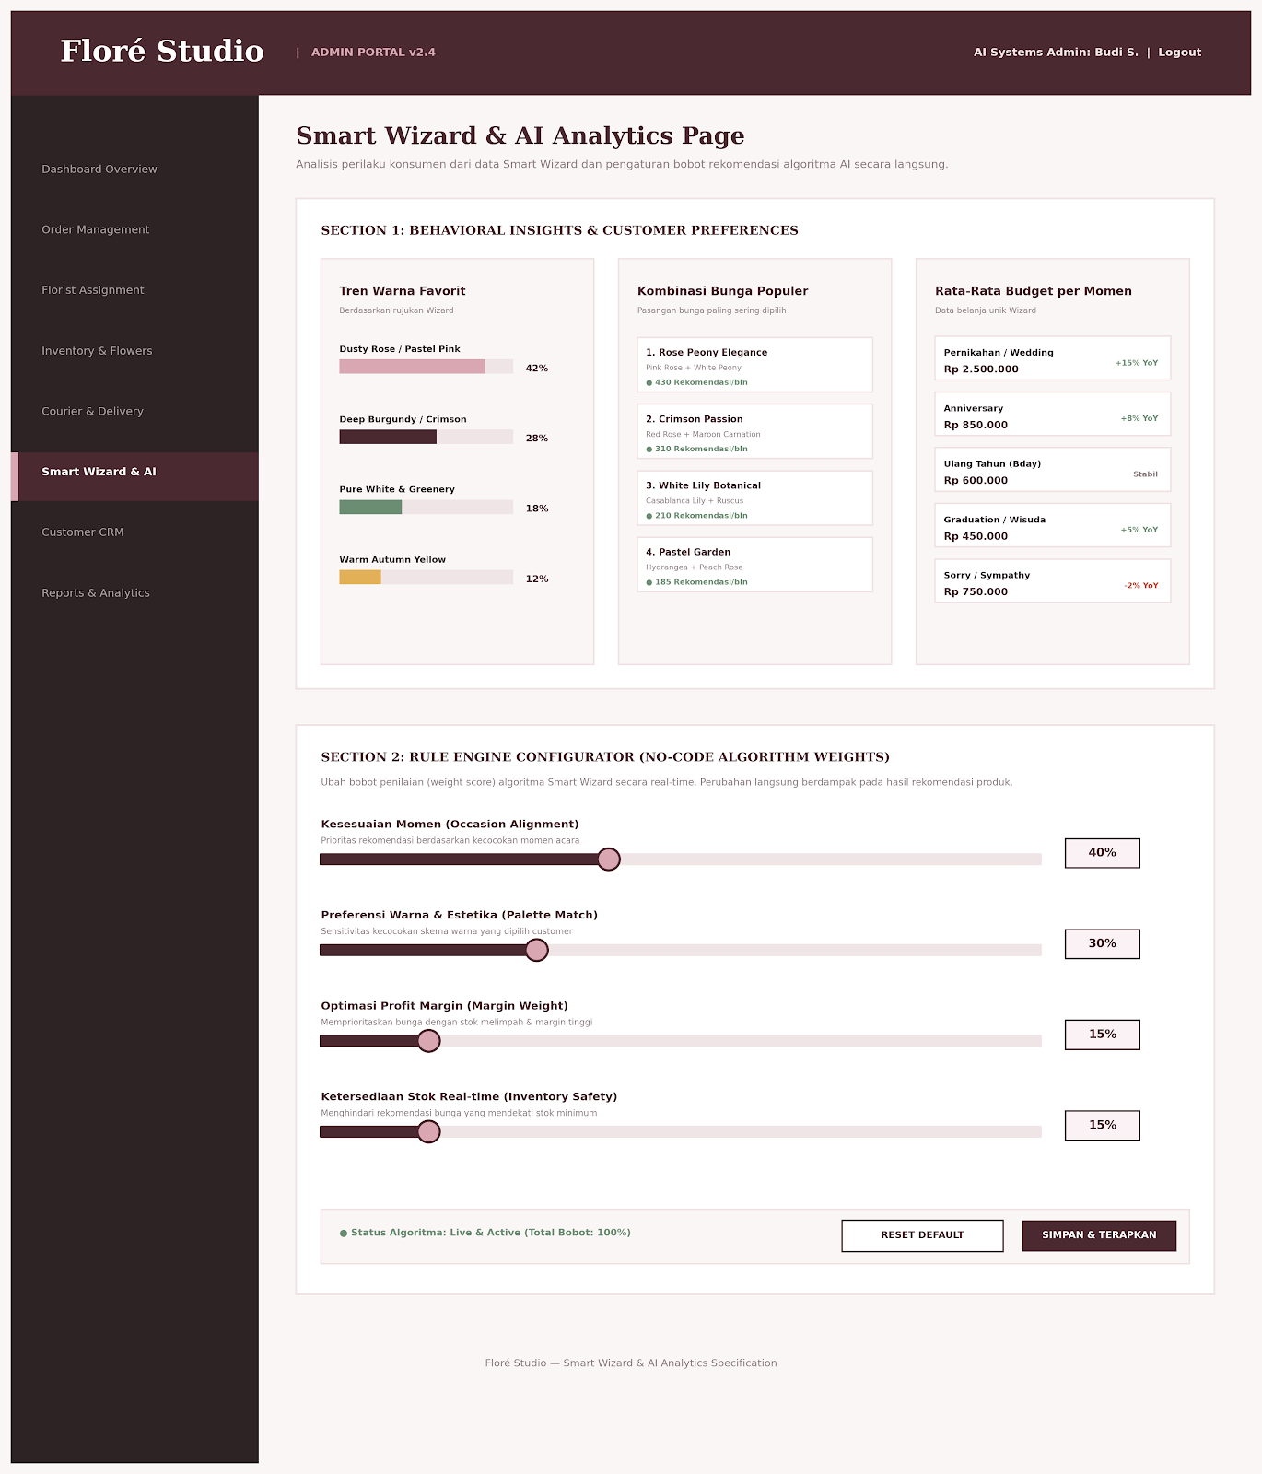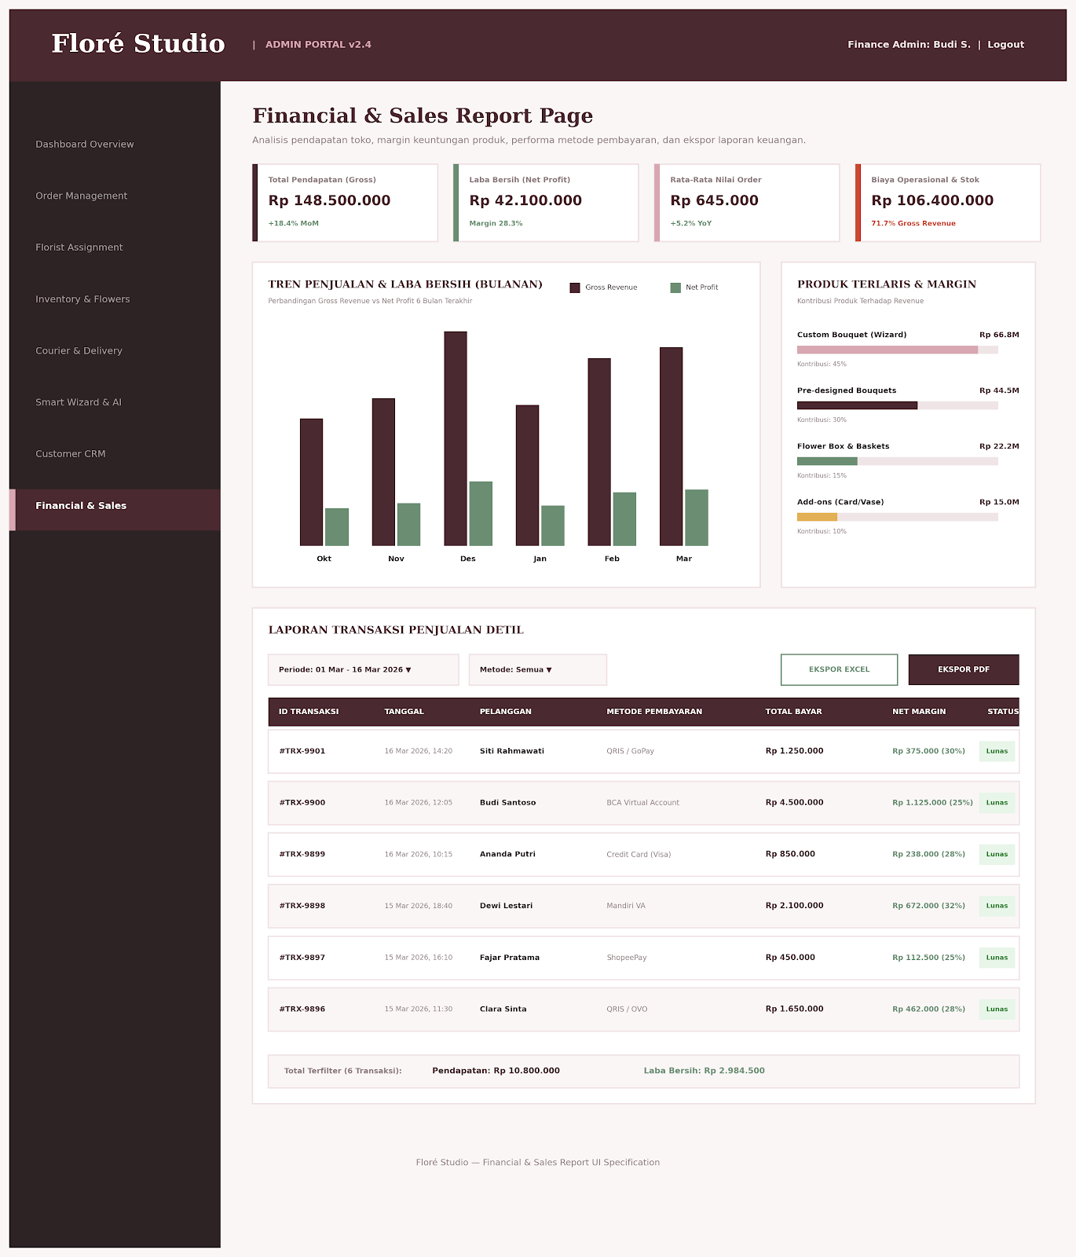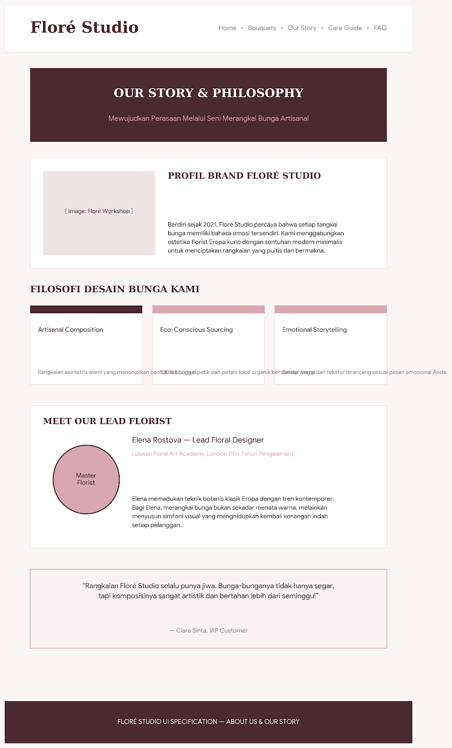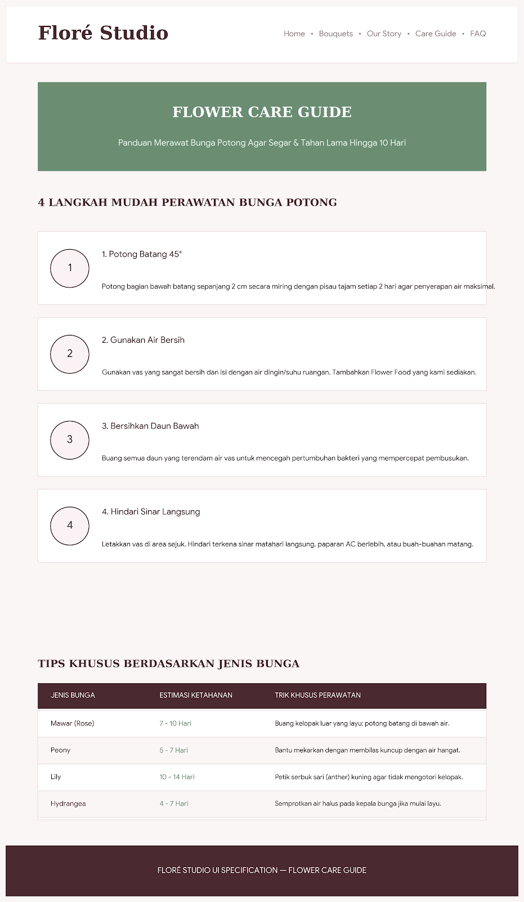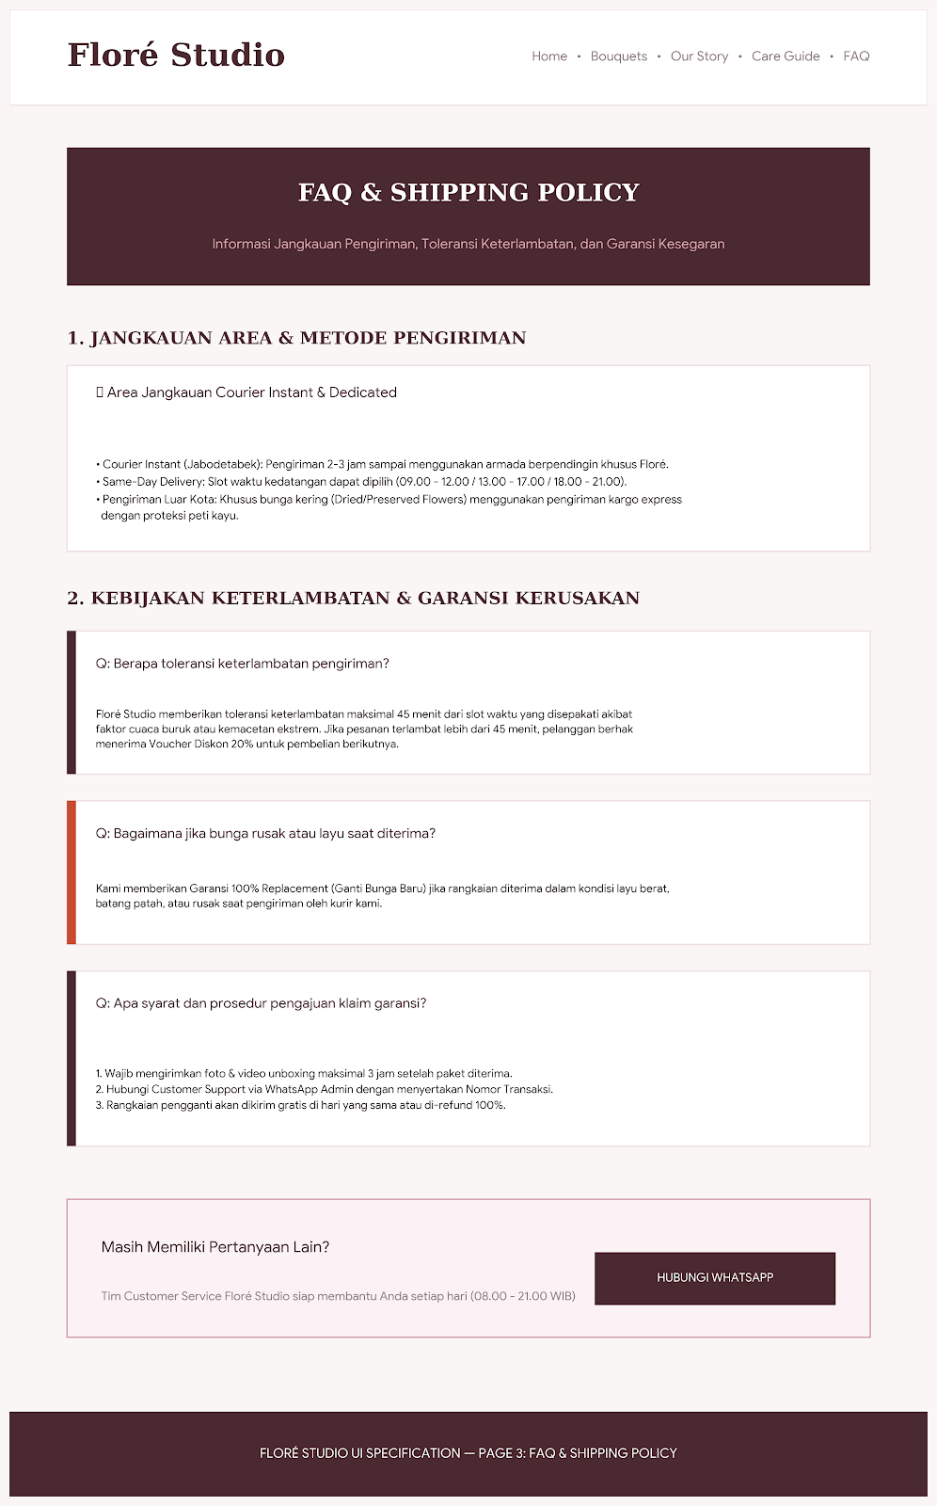

- Customer Portal Wireframes: Includes layouts for User Registration/Login, Catalogue & Filtering, Smart Recommendation Wizard step-by-step form, Shopping Cart, Checkout/Payment Status Upload, and Order Tracking screens.
- Admin Dashboard Wireframes: Includes layouts for the Sales Summary Dashboard, Bouquet & Stock Management Form, Order Status Management List, and Customer Reports screen.
- Screen Flow Diagram: Illustrates the step-by-step user navigation path from the Landing Page $→$ Catalogue / Wizard $→$ Cart $→$ Checkout $→$ Order Confirmation.

4.3 References
- Pressman, R. S., & Maxim, B. R. (2020). Software Engineering: A Practitioner's Approach (9th ed.). McGraw-Hill Education.
- Larman, C. (2015). Applying UML and Patterns: An Introduction to Object-Oriented Analysis and Design and Iterative Development (3rd ed.). Pearson.
- Documentation, PHP Laravel Framework & Bootstrap 5 UI Library.
- Beck, K., Beedle, M., van Bennekum, A., Cockburn, A., Cunningham, W., Fowler, M., Grenning, J., Highsmith, J., Hunt, A., Jeffries, R., Kern, J., Marick, B., Martin, R. C., Mellor, S., Schwaber, K., Sutherland, J., & Thomas, D. (2001). Manifesto for Agile Software Development. Agile Alliance. https://agilemanifesto.org/
- Bootstrap Team. (2023). Bootstrap 5.3 Documentation: Powerful, extensible, and feature-packed frontend toolkit. Bootstrap. https://getbootstrap.com/docs/5.3/
- Laravel. (2023). Laravel 10.x Documentation: The PHP Framework for Web Artisans. Laravel. https://laravel.com/docs/10.x
- Russell, S., & Norvig, P. (2020). Artificial Intelligence: A Modern Approach (4th ed.). Pearson Education.
- Schwaber, K., & Sutherland, J. (2020). The Scrum Guide: The Definitive Guide to Scrum: The Rules of the Game. Scrum.org. https://scrumguides.org/
- Sommerville, I. (2016). Software Engineering (10th ed.). Pearson Education.

4.4 Appendix
- Appendix A: Data Dictionary & Database Schema Definitions.
- Appendix B: Full System Wireframes and UI Mockups.
- Appendix C: Test Cases and Traceability Matrix (FR to NFR mapping).

